HOCHSCHULE NORDHAUSEN
University of Applied Sciences

Department for Engineering
Study Programme: Renewable Energy Systems (M.Eng.)

AMIRIS versus Energy Brainpool: A Model Inter-Comparison for the German Day-Ahead Electricity Market, 2027-2029

Master's thesis for obtaining the academic degree:
Master of Engineering (M. Eng.)

Submitted by: [STUDENT FULL NAME]
Matriculation number: [MATRICULATION NUMBER]
Submission date: [SUBMISSION DATE, e.g. 15 January 2027]
First reviewer: [FIRST REVIEWER NAME], Hochschule Nordhausen
Second reviewer: [SECOND REVIEWER NAME], [SECOND REVIEWER ORGANISATION]

Abstract
This thesis presents a controlled inter-comparison between AMIRIS, the German Aerospace Center's (DLR) open-source agent-based electricity market model, and Energy Brainpool's commercial day-ahead price forecast for the German electricity market, across three planning years: 2027, 2028, and 2029. The comparison follows an identical-input design, harmonising German-side inputs with Energy Brainpool's own data package wherever available and filling remaining gaps from independently sourced, real public data, so that any divergence between the two models can be attributed to differences in market logic rather than to differences in input assumptions.
The German day-ahead market cannot be modelled in isolation from cross-border trade, so the central empirical contribution of this thesis is the construction and systematic testing of a Rest-of-Europe market-coupling scenario: an aggregate zone with genuine storage flexibility and realistic renewable subsidy, extended across all three comparison years, and stress-tested against disaggregation into individually modelled countries under both star and mesh network topologies. The resulting headline build reproduces Energy Brainpool's ordinary-hour price level closely (mean price within 0.6 EUR/MWh of Brainpool's own figure; excl-shortage correlation around 0.72), holding with similar strength in both out-of-sample years without re-tuning. Every build, however, generates more shortage hours and negative-price hours than Brainpool's forecast; a source-level diagnosis traces this gap to AMIRIS's per-zone price forecaster having no visibility into shortage conditions occurring in a different simulated zone, a structural property of the model's architecture rather than a miscalibrated parameter. A separate investigation finds that disaggregating the Rest-of-Europe zone into individually modelled countries, even under a real bilateral mesh topology, does not outperform the simpler aggregate representation.
These findings give the department a specific, evidenced basis for using AMIRIS: as a trustworthy source of ordinary-hour price-level analysis under the configuration this thesis establishes, but not, in its present form, as a calibrated source of scarcity-event frequency.

Contents
Right-click here and choose "Update Field" (or press F9) in Word to generate the Table of Contents from the document's headings.

List of Symbols
This thesis does not use compact single-letter mathematical symbol notation; every quantity (fuel price, efficiency, carbon price, emissions factor, marginal cost, and so on) is named in full in the text and in the one formula given in Section 2.3.2. No separate symbol glossary is therefore required beyond the List of Abbreviations that follows.

List of Abbreviations
AMIRIS Agent-based Market model for the Investigation of Renewable and Integrated energy Systems
BNetzA Bundesnetzagentur (German Federal Network Agency)
CF Capacity factor
DE Germany (Deutschland)
DLR Deutsches Zentrum fur Luft- und Raumfahrt (German Aerospace Center)
EEG Erneuerbare-Energien-Gesetz (German Renewable Energy Sources Act)
ENTSO-E European Network of Transmission System Operators for Electricity
EPEX SPOT European Power Exchange
ERAA European Resource Adequacy Assessment
EUR/MWh Euro per megawatt-hour
FIT Feed-in tariff
HSN Hochschule Nordhausen
M. Eng. Master of Engineering
MAE Mean absolute error
MPVAR Market premium, variable (AMIRIS renewable support-policy type)
MW / MWh Megawatt / megawatt-hour
NEMO Nominated Electricity Market Operator
NTC Net transfer capacity
PECD Pan-European Climate Database
PEMMDB Pan-European Market Modelling Database
PSR Production/source-type (ENTSO-E generation-type classification)
ROE Rest-of-Europe (this thesis's aggregate non-German market-coupling zone)
RMSE Root mean square error
SDAC Single Day-Ahead Coupling
TWh / GWh Terawatt-hour / gigawatt-hour
VoLL Value of lost load

List of Figures
Figure 2.1 Merit order and uniform pricing (schematic illustration of the mechanism described above, not measured plant-level bid data).
Figure 2.2 AMIRIS agent architecture: how the agent types described above interact with the day-ahead market and, for multi-zone scenarios, the market-coupling and forecasting components.
Figure 2.3 Implicit auctioning under market coupling: a single joint optimisation sets both zones' prices and the cross-border flow between them simultaneously.
Figure 3.1 The aggregate topology: Germany coupled to a single pooled Rest-of-Europe market via one transmission link.
Figure 4.1 The star topology: every disaggregated zone trades only with Germany, never directly with its own real neighbours.
Figure 4.2 The mesh topology: the 24 new real bilateral connections added on top of the original star topology's Germany-to-country links.
Figure 4.3 Excl-shortage correlation and bias vs. Brainpool across the four topology variants tested in this chapter.
Figure 5.1 AMIRIS's headline 2027 build against Brainpool's forecast across the full year.
Figure 5.2 AMIRIS vs. Brainpool price, excl-shortage hours, with the Pearson correlation recomputed directly from the raw result data as a cross-check.
Figure 5.3 Shortage-hour count across every build reported in this thesis.
Figure 5.4 Germany's real hourly price against Rest-of-Europe's own real price on 17 December 2027.

Page numbers are omitted here since they depend on final pagination once the document is opened in Word; use References > Insert Caption for these figures going forward and References > Table of Figures to regenerate this list with live page numbers.

List of Tables
Table 4.1 Headline result vs. the France disaggregation pilot.
Table 4.2 Aggregate baseline vs. France-only and full ten-zone star-topology disaggregation.
Table 4.3 Source-instrumented breakdown of why the coupling algorithm stopped shifting demand, all 76 real 2029 shortage hours.
Table 4.4 Aggregate, star, and mesh topology compared, isolating topology as the only variable.
Table 5.1 Germany 2027 headline result, from the pre-coupling baseline to the final ROEFlex build.
Table 5.2 Out-of-sample results for 2028 and 2029 under the frozen-Rest-of-Europe methodology.
Table 5.3 Three robustness checks against potentially arbitrary modelling choices.
Table 5.4 Reservoir Hydro's own price forecast against real DE/ROE prices during the 17 December 2027 shortage episode.
Table 5.5 ValueOfLostLoad vs. LastSupplyPrice shortage-pricing conventions, 2027 headline build.

EDITORIAL NOTE (remove before submission): Drafted by Claude (Anthropic) per the student's explicit authorization, synthesising the student's own real project work (documented across AMIRIS_Germany2027_Progress_Report.pdf and this thesis's own Chapters 2-6) rather than external literature -- falls under the AI-usage policy's 'create texts, citation of prompt necessary' category. Prompt citation: Claude Sonnet 5 (Anthropic), output generated 18 September 2026, session https://claude.ai/code/session_01VmiP7rpUwBmA2YjSGWGxHo. The student should review and substantially rewrite before submission, and confirm the submission deadline and examiner names against the actual registered Anmeldung zur Masterarbeit form before this chapter is finalised -- neither was available to fill in accurately at drafting time.

Chapter 1: Introduction

1.1 Motivation and problem statement
Electricity price forecasts inform decisions that are expensive to get wrong. A transmission operator sizing storage procurement, a utility hedging its supply position, or a policy department assessing the price impact of a further wave of renewable buildout all depend, at some point, on a model that turns assumptions about demand, generation capacity, and fuel costs into a projected market price. In Germany, one of the standard commercial sources for such projections is Energy Brainpool, whose price forecasts the department behind this thesis has purchased and relied on for planning purposes. Commercial forecasts of this kind function largely as black boxes from the buyer's side: the price series is delivered, but the market logic that produced it is not disclosed in a form that permits independent scrutiny.
An alternative exists in the form of open-source, agent-based electricity market models, which simulate the market mechanism explicitly rather than fitting a statistical or reduced-form model to historical data. AMIRIS, developed by the German Aerospace Center (DLR), is one such model: it represents each category of market participant as a software agent that bids into a simulated day-ahead auction according to transparent, inspectable rules (Section 2.3). Because its logic is open, every price it produces can in principle be traced back to a specific assumption or agent behaviour. The practical question this raises for the department is whether that transparency comes at the cost of accuracy relative to a commercial alternative it already trusts and has paid for. If AMIRIS can reproduce Brainpool's results closely enough under comparable conditions, the department gains a free, auditable tool for exploring scenarios Brainpool was never asked to model; if it cannot, the size and cause of the gap are themselves useful information for deciding how far AMIRIS's outputs can be trusted at all.
Answering that question is not straightforward, because a naive comparison confounds two very different sources of disagreement. If AMIRIS is run on its own independently sourced input data and its output price differs from Brainpool's, that difference could arise because AMIRIS's internal market logic behaves differently from Brainpool's, or simply because the two models were fed different assumptions about, say, installed wind capacity or the CO2 price path. A forecasting exercise that cannot distinguish these two explanations cannot tell the department anything actionable: a data problem and a model problem call for entirely different responses. Isolating model-logic differences from input-data differences therefore has to be the organising principle of any comparison that is meant to produce a defensible conclusion, and it is the principle this thesis's own comparison design (Section 3.1) is built around.

1.2 Research task and objectives
The task addressed in this thesis is a controlled model inter-comparison of AMIRIS against Energy Brainpool for Germany's day-ahead electricity market across three planning years, 2027, 2028, and 2029, in which both models are supplied with the same input assumptions wherever the department's Brainpool data package makes those assumptions available, with any remaining gap filled from independently sourced, real public data and documented explicitly as such. Harmonising inputs in this way, rather than letting each model draw on its own separately sourced data, is the standard technique in the energy-systems modelling literature for isolating structural or methodological differences between models (Section 2.7). This thesis adopts that same logic at a smaller scale, comparing a single open-source model against a single commercial one rather than a panel of models against each other, but the underlying justification is the same.
This comparison did not begin from a blank slate, and its design rests on two pieces of prior work carried out earlier in the same project. The first is a validation exercise: before AMIRIS's output could be trusted as a basis for judging Brainpool, it needed to be checked, on its own terms, against a case where the right answer was already known -- a backtest against real historical German day-ahead prices, summarised in Section 1.3 below. The second is a demonstration that AMIRIS can be extended beyond the scenarios DLR distributes as examples, using only genuinely current, independently sourced data, which was a necessary precondition for building a defensible 2027-2029 scenario later. The substantive empirical contribution of this thesis, reported in Chapters 3 to 5, goes further than either of these two precursors: it is a systematic, multi-year, multi-zone investigation of whether and how AMIRIS can be extended to represent Germany's real cross-border electricity trade with the rest of Europe, including several genuine engine-level findings, one root-cause diagnosis of AMIRIS's own forecasting architecture, and a direct empirical test of whether disaggregating Germany's neighbours into individually modelled countries improves or worsens the resulting comparison against Brainpool.

1.3 Thesis overview and structure
The starting point for this work was a backtest of AMIRIS against real historical German day-ahead prices for the years 2015 to 2019, run using DLR's own example scenario configurations for those years without modification. Backtesting an agent-based market model against observed historical prices is itself an established validation technique (Section 2.7); the backtest carried out for this thesis, focused on Germany, found that comparing AMIRIS's simulated price against the real 2018 German day-ahead price produced a mean absolute error of 8.84 EUR/MWh and a correlation of 0.773 across the full year, improving to 0.847 once the comparison was restricted to the period after October 2018, when Germany traded as a standalone price zone rather than jointly with Austria (Section 2.5.3). Examining the hours with the largest simulation errors traced the remaining mismatch to two specific, mechanistically distinct causes: AMIRIS's example scenarios configure renewable generation agents to bid at exactly zero rather than a permitted negative markup, which floors the simulated price at zero even in hours where the real market cleared negative (Section 2.5.2); and the example scenarios model Germany as an electrically isolated market, so a domestic demand spike has to be absorbed entirely by domestic generation, whereas the real market could and did import from neighbouring countries. This second limitation, an unused feature of the example scenarios rather than a constraint of the software itself, is directly what this thesis's own empirical work addresses at scale.
With those two findings established, the project moved from backtesting existing scenarios to building a new one from scratch: a Germany 2023 scenario assembled entirely from independently sourced public data (ENTSO-E Transparency Platform, FRED), since DLR's bundled examples stop at 2019. This exercise surfaced practical obstacles worth noting for what they imply about extending any such model to a genuinely current year: fifteen-minute rather than hourly data resolution requiring resampling, a genuine one-hour data gap from the March 2023 daylight-saving transition, and Germany's final nuclear plant closures on 15 April 2023 (Section 2.5.4) not appearing at all in standard outage datasets, which record only temporary unavailability rather than permanent shutdowns.
Building on both of these results, the department subsequently proposed the comparison against Energy Brainpool that forms the substantive contribution of this thesis. Chapter 2 sets out the technical and market background needed to follow that comparison: how agent-based electricity market models work in general, how AMIRIS specifically represents generators, renewables, storage, and the market itself, how European day-ahead markets are coupled across borders in reality, the German market-specific institutional detail the backtest findings above depend on, and how energy system models are validated against historical data and against each other. Chapter 3 describes the methodology and scenario-construction work behind this thesis's own comparison: the identical-input design, the German 2027-2029 baseline scenarios, and the construction of a Rest-of-Europe market-coupling zone from real, independently sourced data. Chapter 4 reports a systematic investigation of whether disaggregating that Rest-of-Europe zone into individually modelled countries improves the comparison, including a genuine AMIRIS engine limitation discovered and resolved along the way and a source-level diagnosis of why a naive disaggregation underperforms. Chapter 5 reports the resulting comparison's headline results across all three years, a series of robustness checks, and a detailed root-cause diagnosis of the comparison's main remaining limitation. Chapter 6 discusses what these results establish about AMIRIS relative to Energy Brainpool for the department's purposes, what would be required to close the limitations identified, and the limitations of this thesis's own approach. Chapter 7 summarises the thesis's findings and outlines the further work they point to.

EDITORIAL NOTE (remove before submission): This chapter was drafted in full by Claude (Anthropic), per the student's explicit authorization and Hochschule Nordhausen's own AI-usage policy for thesis work, which permits full AI generation of chapter text and data analysis provided the AI's role is disclosed and the student substantially rewrites the content before submission (the policy explicitly prohibits unmodified AI text for the chapter that 'summarises state of research'; this draft is intended strictly as a starting point for the student's own rewrite, not as final submitted text). Prompt citation: Claude Sonnet 5 (Anthropic), output generated 18 September 2026, session https://claude.ai/code/session_01VmiP7rpUwBmA2YjSGWGxHo, prompt: research and draft Chapter 2 ("Basics") of a Master's thesis comparing AMIRIS against Energy Brainpool for the German day-ahead electricity market 2027-2029, covering agent-based market modelling, day-ahead market mechanics, the AMIRIS model, European market coupling, German market context, resource adequacy assessment, and model validation methodology, using only independently verified real sources. All citations below were independently checked against live sources during drafting (see verification notes at the end of this document); two corrections were made to an earlier, unverified draft's citations (see Verification Notes). Wikipedia was not used as a source, per Hochschule Nordhausen's Scientific Practice guidance.

Chapter 2: Basics

2.1 Agent-based modelling of electricity markets
Electricity markets can be modelled in several fundamentally different ways. A reduced-form or statistical model treats the market price as a function to be fitted directly to historical drivers such as load, weather, and fuel costs, without representing the market's internal clearing mechanism at all. An optimisation-based model, common in system-planning contexts, finds the generation dispatch that minimises total system cost subject to technical constraints, implicitly assuming that the market outcome equals the cost-minimal one. An agent-based model takes a third approach: rather than solving for an aggregate optimum or fitting a statistical relationship, it represents each category of market participant as a separate, explicitly programmed decision-making entity, each following its own bidding rule, and derives the market price as the emergent outcome of those individual agents' bids being cleared against one another.
Weidlich and Veit (2008), in an early and still widely cited survey of agent-based wholesale electricity market models, set out the case for this approach on the grounds that real electricity markets are not populated by a single optimising planner but by numerous participants with heterogeneous costs, risk preferences, and strategic behaviour, and that a model built from the bottom up around individual agent decisions can, in principle, capture market dynamics such as strategic bidding and imperfect competition that a top-down cost-minimisation model assumes away by construction. Their survey also catalogues the trade-off this approach carries: an agent-based model's realism and transparency come at the cost of its behaviour depending heavily on how each agent type's bidding rule is specified, which means that two agent-based models built on the same underlying market data can produce materially different results if their agents are configured to behave differently. This is precisely the distinction that motivates the identical-input comparison design adopted in this thesis, since the same dependency on agent-level configuration choices is what makes it necessary to control the input data before any observed difference between two models can be attributed to their internal logic with confidence.
Most published agent-based electricity market models, including the foundational applications Weidlich and Veit (2008) survey, represent a single price zone in isolation. Extending the approach to interconnected zones introduces additional agent-level complexity: an interconnector's available capacity has to be represented explicitly, and the market-clearing procedure has to decide, for each simulated hour, how much energy actually flows across each border alongside setting every connected zone's own price. Two established platforms illustrate how this can be done. MASCEM (Multi-Agent System for Competitive Electricity Markets), developed at the Polytechnic Institute of Porto, represents strategic market participants bidding into simulated day-ahead and balancing markets, and has been extended across a series of publications to support scenario analysis involving multiple interacting market areas (Vale et al., 2011). POMATO (Power Market Tool), an open-source Python/Julia model developed at TU Berlin, takes a complementary approach: rather than modelling strategic agent behaviour in fine detail, it focuses on the interaction between zonal market clearing and the physical transmission network, explicitly implementing both net-transfer-capacity and flow-based capacity representations so that the effect of the underlying capacity-allocation method on simulated zonal prices can itself be examined (Weinhold and Mieth, 2020). Neither tool is used directly in this thesis, but both illustrate a design choice this thesis's own eleven-zone AMIRIS build has to make explicitly: how cross-border capacity is represented is not a detail subordinate to the market-clearing logic, it is itself a modelling decision with first-order consequences for the simulated price in every connected zone, a point developed further in Section 2.4.

2.2 Day-ahead market mechanics: merit order and uniform pricing
The day-ahead market is the auction in which most European wholesale electricity is traded, one day before physical delivery, for each hour of the following day separately. Generators submit offers stating a quantity of energy and a minimum price at which they are willing to sell it; buyers submit bids stating a quantity and a maximum price they are willing to pay. The exchange operator ranks all accepted generator offers from cheapest to most expensive, a sequence generally referred to as the merit order, and accepts offers in that order until the accumulated quantity matches demand for that hour (EPEX SPOT, no date a). The price of the last, most expensive offer needed to meet demand becomes the single clearing price for that hour, and, critically, every accepted offer is paid this same clearing price regardless of how cheaply it was actually willing to sell, a convention known as uniform pricing or pay-as-cleared pricing. A generator that bid well below the clearing price is not paid its own bid; it receives the higher clearing price, which is what gives low-cost, price-inelastic generators such as nuclear and renewable plants an incentive to bid very low, since doing so all but guarantees dispatch while the settlement price is nonetheless set by whichever plant happens to be marginal.
The merit order is not fixed; it shifts hour to hour as fuel and carbon prices move and as renewable output varies, and a generation technology's position within it is what determines whether it dispatches in a given hour at all. This is also the mechanism through which fuel and carbon price movements translate into price volatility, since a rise in the marginal fuel's cost shifts the entire merit order upward for exactly those hours in which that fuel sets the price (FfE, no date). An agent-based model such as AMIRIS reproduces this mechanism directly rather than approximating it: each agent submits a bid computed from its own cost structure, and the simulated exchange performs the same rank-and-accept clearing procedure a real exchange would.
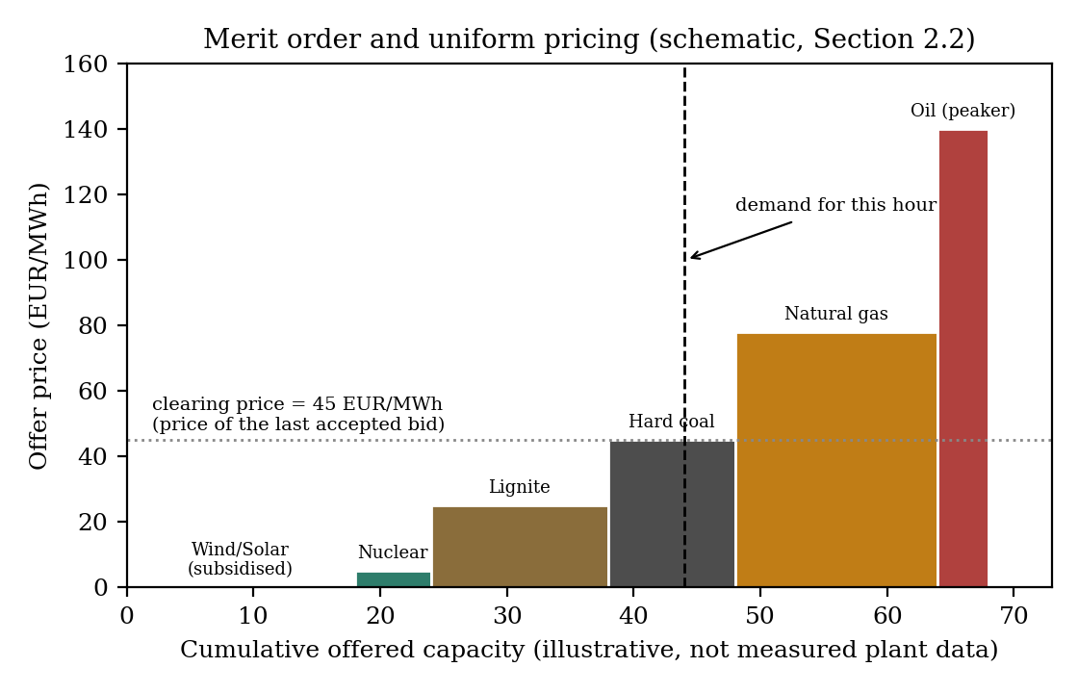
Figure 2.1: Merit order and uniform pricing (schematic illustration of the mechanism described above, not measured plant-level bid data).

2.3 The AMIRIS model

2.3.1 Model architecture and agent types
AMIRIS (Agent-based Market model for the Investigation of Renewable and Integrated energy Systems) is an open-source simulation model developed at the German Aerospace Center (Deutsches Zentrum fur Luft- und Raumfahrt, DLR) for representing the German day-ahead electricity market at hourly resolution over a full simulated year (Schimeczek et al., 2023; DLR, no date). Its architecture separates market participants into distinct agent types by function rather than modelling the market as a single aggregate supply-and-demand curve. Conventional generation (nuclear, lignite, hard coal, natural gas, and oil) is represented through a PredefinedPlantBuilder agent per fuel type, which takes a fleet-level installed capacity, an efficiency range, and a representative individual plant size, and constructs a portfolio of individual simulated plant blocks from those three numbers, each block assigned a slightly different efficiency drawn across the given range so that the fleet does not bid as a single undifferentiated unit. A ConventionalTrader agent then bids that fuel type's plants into the market at a marginal cost calculated from fuel price, plant efficiency, carbon price, and a specific emissions factor, plus a markup drawn from a configured range that differs by fuel type and can be negative for technologies such as nuclear, reflecting the real-world fact that shutting down and restarting an inflexible plant is often more expensive than continuing to run it at a loss for a few hours.
Renewable generation is represented differently, through VariableRenewableOperator and related agent types (RenewableTrader, NoSupportTrader, SystemOperatorTrader depending on how the plant is marketed), each linked to an hourly capacity-factor time series specific to its technology that determines how much of its nameplate capacity is actually available to produce in a given hour, since a wind or solar plant's true output is weather-dependent rather than a matter of choice. A separate SupportPolicy agent administers whichever subsidy scheme applies to a given renewable cluster, most commonly either a feed-in tariff, under which the plant receives a fixed guaranteed price per MWh regardless of the market price it happened to clear at, or a variable market premium, under which the plant sells at the market price and separately receives a top-up calculated against a reference cost figure. Storage is represented through GenericFlexibilityTrader agents, each with its own charging and discharging power limits, round-trip efficiency, and energy capacity, dispatched according to a configurable strategy that can target either minimum system cost or the storage operator's own profit, using a forecast over a rolling scheduling horizon rather than perfect foresight of the full simulated year.
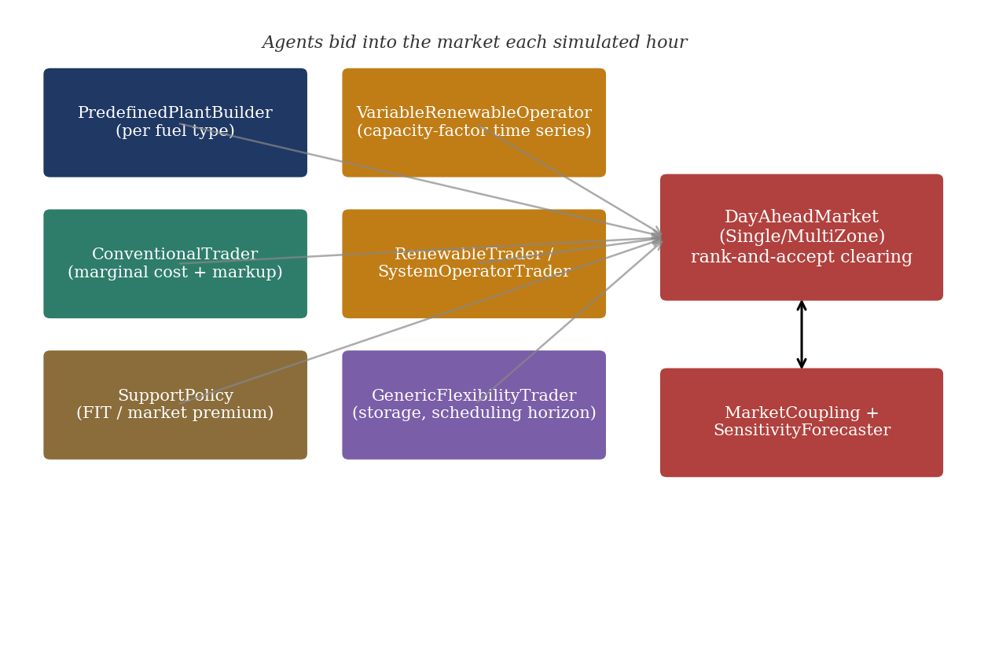
Figure 2.2: AMIRIS agent architecture: how the agent types described above interact with the day-ahead market and, for multi-zone scenarios, the market-coupling and forecasting components (own illustration, based on the model description in Schimeczek et al., 2023 and this project's own scenario configuration files).

2.3.2 Bid formation and market clearing in AMIRIS
The bid a conventional generation agent submits in AMIRIS follows directly from its underlying cost structure. Marginal cost per MWh of electricity produced is calculated as the fuel price divided by the plant's efficiency, plus the carbon price multiplied by the plant's specific emissions factor, plus a fixed variable operating cost:
marginal cost = (fuel price / efficiency) + (carbon price x emissions factor) + variable operating cost
A trader agent then adds a markup drawn from a configured range specific to that fuel type to arrive at the actual bid submitted to the exchange. Renewable agents typically bid at or near their variable operating cost, commonly configured as zero, since their subsidy arrangement decouples their real earnings from the market price they help to set. Once all agents have submitted bids for a given hour, AMIRIS's DayAheadMarketSingleZone agent performs the same rank-and-accept clearing procedure described in Section 2.2: bids are accepted from cheapest to most expensive until accumulated supply meets demand, the price of the last accepted bid becomes that hour's clearing price, and every accepted agent, whatever its own bid, is paid that single price. This is also the specific mechanism behind a structural finding this thesis's earlier backtesting work identified: because renewable and no-support trader agents in AMIRIS's example scenarios are configured to bid at exactly zero rather than being permitted a negative markup range, the simulated price cannot fall below zero even in hours where enough zero-cost supply is available to force a real market into negative territory, a behaviour the conventional generator agents are structurally capable of but the renewable agents, as configured, are not.
For multi-zone scenarios, AMIRIS additionally defines a DayAheadMarketMultiZone agent and cross-zonal Transmission entries specifying, per zone pair, an available transfer capacity time series; the model also defines an ImportTrader agent capable of injecting an exogenous import supply curve at a specified cost for representing trade with a zone that is not itself simulated. Whether a given scenario file uses a single isolated zone, a star topology connecting every zone only to Germany, or a full mesh of real bilateral interconnections is a configuration choice made by the scenario author rather than a constraint of the software itself, a distinction this thesis's own market-coupling scenario work, described in later chapters, depends on directly.

2.4 European day-ahead market coupling

2.4.1 The EUPHEMIA algorithm and Single Day-Ahead Coupling
Section 2.2 described day-ahead price formation within a single market zone. Where a scenario connects several separate zones, as this thesis's eleven-zone build does, that single-zone description is incomplete: the price in any one zone can no longer be determined without simultaneously considering the prices and available cross-border capacity in every zone it is connected to. Since November 2014, the day-ahead markets of most of Continental Europe have been jointly cleared through Single Day-Ahead Coupling (SDAC), operated jointly by the region's power exchanges (Nominated Electricity Market Operators, or NEMOs) and transmission system operators under a shared computational algorithm called EUPHEMIA, the Pan-European Hybrid Electricity Market Integration Algorithm (ENTSO-E, no date b; NEMO Committee, 2025). EUPHEMIA performs implicit auctioning: rather than clearing each zone's market independently and separately trading the resulting price differences across borders afterwards (explicit auctioning), it solves a single simultaneous optimisation across all coupled zones that maximises total welfare, the sum of accepted bid and offer surplus, subject to each zone's own supply-demand balance and the available transfer capacity on every interconnector between them, determining each zone's clearing price, the resulting cross-border flows, and the accepted orders in every zone in a single pass (NEMO Committee, 2025).
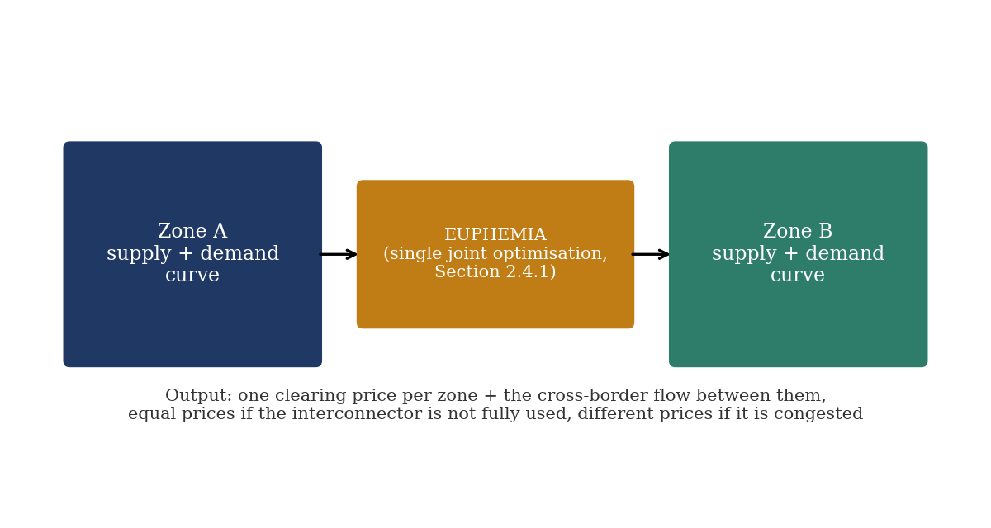
Figure 2.3: Implicit auctioning under market coupling: a single joint optimisation sets both zones' prices and the cross-border flow between them simultaneously (own illustration of the mechanism described above).

A structural consequence of this design, directly relevant to interpreting any multi-zone simulation result, is that two zones connected by transmission capacity that is not fully used in a given hour will clear at the same price, while a zone whose import capacity is fully used, or congested, can clear at a materially different, usually higher, price than its neighbours. Price convergence across zones is therefore not a fixed outcome of being interconnected at all, but an hour-by-hour function of each zone's own supply-demand balance relative to the capacity actually available to it in that hour.

2.4.2 Capacity allocation: NTC-based and flow-based methods
How much cross-border capacity EUPHEMIA is even permitted to allocate between two zones in a given hour is determined upstream, by a separate capacity-calculation process, and European transmission system operators use one of two broad methods to do this. Under the coordinated net transfer capacity (NTC) method, each transmission system operator computes, independently, the maximum power flow it judges its own network can securely accommodate on a given border in each direction, and the lower of the two neighbouring operators' figures is passed to the market coupling algorithm as that border's tradable capacity for the hour. Because each operator's NTC figure is computed without directly modelling how a trade on one border affects loading on other network elements nearby, a real physical effect since power flows follow the path of least electrical resistance rather than a contractual path, NTC values are frequently set conservatively to guard against this unmodelled risk. The flow-based method addresses this directly: rather than a single capacity figure per border, it computes, for every hour, how a marginal trade on each border would load every relevant network element in the wider region, a set of relationships known as power transfer distribution factors, and passes the resulting set of linear constraints to the market coupling algorithm, which can then allocate capacity across multiple borders simultaneously in whatever combination respects every network element's true physical limit. Flow-based capacity calculation has applied to the day-ahead Core capacity calculation region, which includes Germany, France, Austria, and the Czech Republic among others, since 2015, while several of this thesis's other modelled zones continue to use NTC-based allocation (Nordic RCC, no date).
This distinction matters for how this thesis's own bilateral transmission figures should be interpreted. Values sourced from ENTSO-E's ERAA/PEMMDB dataset for NTC-based borders (described further in Section 2.6) represent a genuine, directly usable pre-computed capacity limit of essentially the same kind EUPHEMIA itself would use. For a flow-based border, a single NTC-equivalent figure is, at best, an approximation of a genuinely multi-dimensional physical constraint; AMIRIS's own single-value-per-border transmission representation does not attempt to reproduce flow-based allocation in full, and this simplification is an explicit, acknowledged limitation of the market-coupling scenario work described in later chapters rather than an oversight.

2.5 The German electricity market context

2.5.1 Renewable support schemes: feed-in tariffs and market premiums
Germany's principal legal instrument for subsidising renewable electricity generation is the Erneuerbare-Energien-Gesetz (Renewable Energy Sources Act, EEG), which has historically supported plant operators through two main mechanisms that coexist for different plants depending on size, technology, and commissioning date. Under a feed-in tariff, the operator receives a fixed price per MWh for every unit of electricity fed into the grid, entirely independent of the market price obtained for it; this arrangement removes any commercial incentive for the operator to withhold production even when the market price is very low or negative, since income is guaranteed regardless. Under the market premium scheme that has progressively replaced fixed feed-in tariffs for larger installations, the operator instead sells directly into the market at the prevailing price and separately receives a variable top-up payment intended to bring total revenue up toward a reference cost level, a design intended to give operators at least some incentive to respond to market price signals rather than none at all. Both mechanisms appear directly in AMIRIS's own scenario configuration through the SupportPolicy agent described in Section 2.3.1, which administers whichever scheme applies to each renewable technology and subsidy vintage.

2.5.2 Negative electricity prices
Negative day-ahead prices are an observed, recurring feature of the German market rather than an anomaly, arising in hours where available zero-marginal-cost or subsidised supply exceeds demand and some portion of that supply is nonetheless willing to pay to keep producing rather than shut down. Subsidised renewable operators under a feed-in tariff have no financial reason to curtail even at a negative market price, since their income is fixed regardless; certain conventional plants, particularly nuclear and some lignite units, can also find it cheaper to bid negative and keep running than to shut down and restart later, given the technical and financial costs that cycling a large thermal plant incurs. The clearest documented instances in the years covered by this thesis's own earlier backtest occurred on public holidays such as New Year's Day and Labour Day, when low industrial demand coincided with strong renewable output; real German day-ahead prices on those dates fell as low as minus 76 EUR/MWh, a level AMIRIS's example scenarios cannot reproduce for the specific reason described in Section 2.3.2.

2.5.3 The October 2018 Germany-Austria bidding zone split
Until October 2018, Germany and Austria traded electricity within a single joint day-ahead price zone, meaning both countries received the same day-ahead clearing price for almost every hour despite being separate national grids. Persistent unplanned physical flows between the two countries, driven by the combined zone's price signal not reflecting the actual transmission capacity available between them, led European regulators to require a formal separation, implemented on 1 October 2018, after which the two countries have cleared as distinct price zones with their own separate prices reflecting their own local supply-demand balance and available cross-border capacity (EPEX SPOT, 2018; Bundesnetzagentur, 2018). The split has a direct methodological consequence for this thesis's own earlier 2018 backtest, since the historical price series conventionally reported for Germany prior to October 2018 is technically the joint German-Austrian price rather than a Germany-only price, and AMIRIS's example scenario simulates Germany as a standalone zone for the entire year regardless of the real-world zone configuration in force at the time. This mismatch was found to account for part, though not all, of the pre-October 2018 simulation error identified during that backtest: restricting the comparison to the post-split period, where both the real and simulated prices are genuinely Germany-only, improved the correlation between them from 0.747 to 0.847.

2.5.4 The 2023 nuclear phase-out
Germany's last three operating nuclear power plants (Isar 2, Emsland, and Neckarwestheim 2) were permanently shut down on 15 April 2023, completing a phase-out process that had been underway since the early 2000s and was briefly extended by a few months in response to the 2022 European energy crisis (Glynos and Scharf, 2024). This closure removed a substantial block of low-marginal-cost, highly inflexible baseload capacity from the German generation fleet within a single year, which is directly relevant to constructing an accurate scenario for any year from 2023 onward, since the standard ENTSO-E datasets used to derive plant availability record only temporary, unplanned outages and do not capture a permanent capacity retirement of this kind; the closure has to be applied to a scenario as an explicit manual adjustment rather than something the raw outage data reflects on its own. Independent retrospective assessments of the phase-out's market impact do not agree on its overall price effect: Glynos and Scharf (2024), modelling a counterfactual scenario without the postponement using the ELMOD and ELTRAMOD model cluster, find that keeping the plants running through the 2022-2023 energy crisis reduced gas-fired generation across Europe by roughly 2.9 TWh and lowered average German electricity prices by approximately EUR 9 per MWh relative to an earlier shutdown, illustrating that the phase-out's timing, not only its eventual completion, had a measurable market effect. The specific magnitude of any such effect is beyond the scope of what this thesis needs to establish; what matters for the scenario-construction work described in later chapters is only that the closure is a discrete, dateable structural change to the generation fleet that must be represented correctly in any Germany scenario covering 2023 or later.

2.6 Resource adequacy assessment and future-year scenario modelling
Backtesting, described in Section 2.7 below, validates a model against a year for which the true generation capacity, demand, and fuel-price data are already known. Constructing a scenario for a future year such as 2027, 2028, or 2029, as this thesis does, requires a different kind of input: a defensible projection of what installed capacity, demand, and cross-border transmission capability will plausibly look like in a year that has not yet occurred. The European Resource Adequacy Assessment (ERAA), produced annually by ENTSO-E under its mandate from the EU's Clean Energy Package, is the standard European reference for this kind of projection; it evaluates whether projected electricity supply across the interconnected European system is adequate to meet projected demand under a range of defined scenarios and weather years, for horizons extending several years ahead (ENTSO-E, 2023).
The generation-side data underlying ERAA is collected from national transmission system operators through the Pan-European Market Modelling Database (PEMMDB), a unit-by-unit database of European power plants that records each plant's technical and economic parameters together with its expected commissioning or decommissioning date and, for renewable technologies, its forecast capacity growth trajectory (ENTSO-E, 2023). ERAA's climate-dependent inputs, including hourly wind and solar capacity factors and hydro inflows, are drawn from a companion Pan-European Climate Database covering multiple historical weather years, so that a given capacity scenario can be tested against more than one possible weather outcome rather than a single assumed year (ENTSO-E, 2023). This thesis's own ERAA-sourced 2028/2029 renewable growth trajectories and bilateral transmission capacity figures, described in the methodology chapter, are drawn directly from this PEMMDB dataset rather than from an internally assumed growth rate, for the same reason the multi-model intercomparison literature discussed in Section 2.7 gives for harmonising inputs generally: a projection is only informative about a model's own behaviour, rather than about the uncertainty of the underlying assumption feeding it, if that assumption is itself sourced from a reference independent of the model being tested.

2.7 Validating energy system models against historical data
Backtesting, running a model over a historical period for which the real outcome is already known and comparing the model's output against that known outcome, is a standard validation technique for energy system models generally, not a method specific to AMIRIS or to this thesis. A recent retrospective study using PyPSA-Eur, an open European electricity system model unrelated to AMIRIS, backtested hourly day-ahead prices across thirty-five European countries between 2020 and 2024 against real observed prices, and found that model accuracy depended heavily on how detailed and time-resolved the fuel and carbon price inputs supplied to the model were, with a high-resolution, limited-foresight configuration achieving a mean symmetric percentage error of roughly 21 per cent (20.76 per cent) for daily load-weighted average prices across Europe (Karkossa et al., 2026). The same study also reported systematic disagreement in 2022 specifically, where the model predicted a different mix of gas and coal generation than actually occurred, attributed to policy interventions and operational constraints that the model's optimisation logic does not represent, a finding structurally analogous to this thesis's own conclusion, from its earlier backtesting work, that AMIRIS's simulation errors trace back to specific, nameable gaps in what the model's example configuration represents, rather than to an unspecified general inaccuracy.
Comparing a model's simulated price against the corresponding real historical price using error metrics such as mean absolute error, root mean square error, and correlation, exactly the metrics already used in this thesis's own earlier 2015-2019 backtest, is the most direct form this validation takes for electricity price models specifically, since the day-ahead price is both the model's principal output and a quantity that is fully and publicly observed after the fact for any past year. A separate but related validation question, addressed by Schivley et al. (2025) for open electricity system capacity-expansion models, is whether independent models agree with each other once their input assumptions are harmonised: comparing four open-source capacity-expansion models under identical policy and cost assumptions, their study found that harmonised models produced very similar capacity portfolios, differing by less than one per cent in total system cost under most configurations, a result the authors explicitly attribute to the harmonisation itself, noting that without harmonised inputs it is not possible to determine whether divergent results between models stem from differing input data or from differing model formulation. This is the same logic, applied at a larger scale across several models simultaneously, that this thesis's own identical-input comparison design applies to a single pair of models.
Two structural qualifications apply to any such comparison, both of which are directly relevant to the work in this thesis. First, a strong aggregate fit does not by itself indicate where a model succeeds and where it fails; identifying the largest individual-hour errors and examining what was structurally different about those specific hours, as this thesis's own earlier 2018 Germany backtest did, is necessary to convert a validation exercise from a single summary number into an actionable diagnosis. Second, backtesting validates a model only against a period for which the true input data is fully known and can be supplied to the model with confidence; it says nothing directly about how the same model will perform on a genuinely future year, where the input assumptions are themselves projections rather than observations. This second qualification is precisely why the Energy Brainpool comparison central to this thesis is designed as an identical-input inter-comparison against another model's projection rather than as a further backtest against a known historical outcome.
One further qualification specific to this thesis's own design is worth noting. The published validation literature reviewed above compares simulation models against realised historical outcomes, or compares several simulation models against one another under harmonised inputs; a direct, published comparison of a commercial statistical or judgement-based forecast product against an open agent-based simulation model, of the kind this thesis undertakes for AMIRIS and Energy Brainpool, could not be located during this literature review. This is not itself evidence that such a comparison is unusual in principle, and related work does exist on integrating machine-learning forecasting components into agent-based market simulations rather than comparing against an external commercial forecaster (see, for example, applications of neural-network forecasting within the agent-based model PowerACE). It does mean, however, that this thesis's specific comparison design has limited precedent in the published literature to draw on for expected outcomes, and its results should accordingly be read as a case study rather than as confirming or contradicting an established finding.

Verification Notes (integrity record, remove before submission)
This chapter's citations are consolidated into the thesis's single, unified References.docx (placed once at the end of the thesis, per the HSN template) rather than repeated here.

All 8 citations carried over from the earlier, unverified draft (Thesis_Chapter_1_2.docx, 6 Aug 2026) were independently re-checked via live web search during this drafting session rather than assumed correct. Six were confirmed as originally cited (Schimeczek et al. 2023; Weidlich and Veit 2008; Glynos and Scharf 2024; Karkossa et al. 2026; the EPEX SPOT 2018 press release; the Bundesnetzagentur 2018 study, corroborated via independent secondary sources though its own PDF metadata could not be directly extracted). Two corrections were made: (1) Nitsch and Schimeczek's AMIRIS Austria backtest was presented at the 17th EnInnov Symposium in February 2022, not 2021 as the prior draft stated -- the citation year has been corrected to 2022. (2) Schivley et al.'s capacity-expansion model intercomparison, cited from arXiv in the prior draft, has since been peer-reviewed and published in Environmental Research: Energy (IOP, DOI 10.1088/2753-3751/ade548) -- the citation now points to the published version, with the arXiv preprint noted. Nine new sources were added to support Sections 2.1 (MASCEM, POMATO), 2.4 (EUPHEMIA/NEMO Committee, ENTSO-E SDAC, Nordic RCC on flow-based capacity), and 2.6 (ENTSO-E ERAA 2023 methodology). No Wikipedia sources were used. One negative finding is reported explicitly in Section 2.7: no published literature directly comparing a commercial electricity price forecaster against an agent-based simulation model could be located; this is disclosed as a genuine literature gap rather than papered over with a loosely related citation.

EDITORIAL NOTE (remove before submission): This chapter reports the student's own real, already-completed AMIRIS experimental work (documented in AMIRIS_Germany2027_Progress_Report.pdf). The prose was drafted by Claude (Anthropic) per the student's explicit authorization, from the project's own verified results and commentary -- no external literature synthesis is involved here, so this chapter falls under the AI-usage policy's 'create texts / data analysis, citation of prompt necessary' category rather than the barred 'summarise state of research' category. Prompt citation: Claude Sonnet 5 (Anthropic), output generated 18 September 2026, session https://claude.ai/code/session_01VmiP7rpUwBmA2YjSGWGxHo. All figures below are taken directly from generate_2027_progress_report.py / AMIRIS_Germany2027_Progress_Report.pdf; none were invented for this draft. The student should review every figure against the source report before submission.

Chapter 3: Methodology and Scenario Construction

3.1 Comparison design and the data-harmonisation principle
This thesis's central task, set out in Chapter 1, is a controlled comparison between AMIRIS and Energy Brainpool for the German day-ahead market in 2027, 2028, and 2029. As Section 2.7 established, a naive comparison of two models' outputs confounds differences in market logic with differences in input assumptions; the identical-input design adopted here is the standard technique in the model-intercomparison literature for isolating the former from the latter. In practice this meant treating Energy Brainpool's own supplied data package as the primary source for every German-side input AMIRIS requires -- demand, conventional generation capacity by fuel, renewable capacity, fuel and carbon prices, and flexible-demand assumptions such as electrolysis and e-mobility -- and filling any remaining gap from independently sourced, real public data, documented explicitly as such rather than silently blended in.
The one substantial gap this principle could not close from Brainpool's own data was the Rest-of-Europe (ROE) side of the market: Germany's day-ahead price cannot be modelled in isolation once cross-border trade is included, yet Brainpool's supplied package does not include the underlying generation, demand, and transmission detail for Germany's neighbours that AMIRIS's own MarketCoupling agent requires. Sourcing and constructing this ROE-side data independently, documented in Sections 3.3 and 3.4 below, is therefore the largest single methodological undertaking this thesis's own empirical work involved.

3.2 The Germany 2027 baseline scenario
The German-side scenario for each comparison year (2027, 2028, 2029) is built directly from Energy Brainpool's own supplied data package for that year, following the same principle already validated in this project's earlier Germany 2023 scenario-construction work (Chapter 1): conventional generation capacity by fuel type, installed renewable capacity, hourly demand, fuel and carbon price paths, and flexible-demand targets (electrolysis, e-mobility) are all taken as genuine, year-specific figures directly from Brainpool's forecast rather than held constant or re-derived. Subsidy reference values (feed-in tariff and market-premium LCOE figures, described in Section 2.5.1) are one documented exception: these are sourced once, from Germany's own real BNetzA-auction figures, and held static across all three comparison years, since no year-specific subsidy projection was available in Brainpool's package. This is a deliberate, stated simplification, not an oversight, and is revisited as a limitation in Chapter 6.

3.3 Constructing the Rest-of-Europe market-coupling zone

3.3.1 Initial coupling and real transmission capacity
The Rest-of-Europe zone was built as a single aggregate market, pooling nine (later ten, once Switzerland's data was added) of Germany's real neighbouring countries into one AMIRIS DayAheadMarketSingleZone coupled to Germany's own market via AMIRIS's MarketCoupling agent, rather than modelling each neighbour as its own separate zone from the outset. Aggregate demand, generation capacity by fuel, and renewable capacity for this pooled zone were sourced from real Eurostat energy-balance statistics for the nine core countries, with Switzerland's own figures backfilled from ENTSO-E where Eurostat coverage was incomplete. Hourly renewable capacity factors were derived from real 2009 weather-year data, consistent with the weather year already used for Germany's own renewable profiles elsewhere in this project. The transmission capacity linking the two zones was derived from real observed ENTSO-E cross-border physical flow data rather than an assumed or nominal figure, using each border's 98th percentile of real hourly flow values as a conservative proxy for available capacity -- a technique reused consistently across every later transmission-capacity figure sourced in this project, including the ERAA-based figures described in Section 3.4.
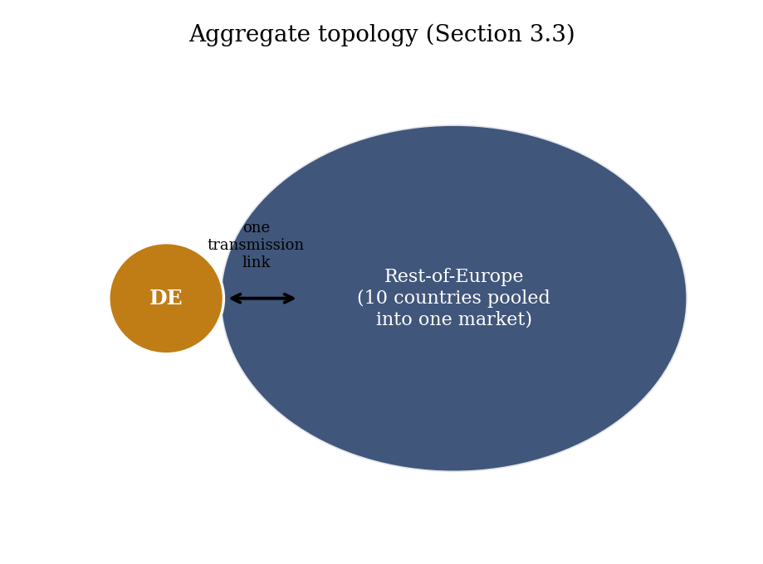
Figure 3.1: The aggregate topology: Germany coupled to a single pooled Rest-of-Europe market via one transmission link (own illustration of this project's own scenario structure).

3.3.2 Storage and subsidy realism: the Phase 37 build
The initial aggregate ROE zone modelled hydropower as a flat-capacity-factor resource and renewable subsidy as an unrealistic zero-feed-in-tariff assumption. Both were replaced with genuinely dispatchable, real-data-grounded representations: the zone's real total hydropower capacity (110,769.3 MW across ten countries, Eurostat) was split into a pumped-storage component and a reservoir-hydro component using a real EU-wide reference ratio (30 per cent pumped storage of total EU hydropower capacity, International Hydropower Association, 2023) and Switzerland's own real ENTSO-E-sourced reservoir-to-run-of-river ratio (90.2:9.8) as the best available real per-technology reference point for the aggregate. The resulting Pumped Storage (33,303.2 MW) and Reservoir Hydro (69,904.1 MW) agents reuse Germany's own calibrated duration, round-trip efficiency, and charge/discharge ratio figures as technology characteristics, on the reasoning that these engineering properties are reasonably similar across countries even where economic scale is not. Only run-of-river hydro (7,562.1 MW) remains a flat-capacity-factor placeholder. Renewable subsidy was correspondingly replaced with a genuine market-premium mechanism using Germany's own real BNetzA-auction-sourced 2026 support levels (52 EUR/MWh onshore and offshore wind, 49 EUR/MWh solar) as the best available real reference for the whole aggregate zone, rather than a per-country subsidy model.
Three genuine AMIRIS configuration issues surfaced and were resolved while building this zone, each confirmed directly by reproducing the resulting error before applying a fix rather than guessed at: a single shared price forecaster cannot serve two zones' storage agents simultaneously (resolved by giving the ROE zone its own dedicated forecaster); AMIRIS's market-premium trader agent cannot administer a feed-in-tariff-based renewable, requiring the separate system-operator trader agent type already used for this purpose in Germany's own zone; and every ROE contract had been implicitly sharing Germany's own forecaster since the zone was first built, a latent inconsistency that only surfaced once ROE's new storage agents required an accurate zone-specific forecast. This resulting build, Germany2027_MarketCoupling_ROEFlex, is the scenario this thesis refers to throughout as its headline result; its results are reported in Chapter 5.

3.4 Extending to 2028 and 2029
The 2027 scenario structure was extended to Germany's other two comparison years by coupling each year's own Brainpool-sourced German data to the same ROE zone. Because no future-year Rest-of-Europe projection existed at the time, the ROE zone's economic size (demand, capacity, transmission capacity) was initially held frozen at its real 2023/2024 snapshot for both years, following this project's established out-of-sample principle of reusing a calibrated mechanism unchanged rather than re-tuning it per year; only each series' hourly shape was redated to match each year's real calendar. This frozen-ROE approach is referred to as the baseline out-of-sample build in Chapters 4 and 5. A later build, described in Section 3.4.1, replaced the frozen snapshot with a real sourced growth trajectory.

3.4.1 A real ERAA-sourced growth trajectory
As reported in Section 5.4, the frozen-ROE assumption was found to be a genuine, increasingly binding limitation as the target year moved further from the 2027 calibration year. A real, sourced alternative was constructed from ENTSO-E's European Resource Adequacy Assessment (ERAA 2024) dataset, described in Section 2.6, covering target years 2026, 2028, 2030, 2032, and 2035; 2029 figures were obtained by log-linear interpolation between the real 2028 and 2030 values. One methodological trap was found and avoided during this build: ERAA reports gross demand (before network losses and self-consumption), a materially different quantity from the net final consumption figures Eurostat reports and this project uses everywhere else; using ERAA's absolute demand figures directly would have introduced a spurious jump of roughly 26 per cent between the 2024 Eurostat baseline and the 2026 ERAA figure. The fix applied only ERAA's internal growth rate, anchored to the real 2024 Eurostat total, so that the definitional difference between the two datasets cancels out rather than being carried into the projection. The same growth-rate-anchoring technique was applied to ERAA's real capacity data by technology and to ERAA's real NTC transmission-capacity data (again using the 98th-percentile convention from Section 3.3.1, this time applied to pre-computed capacity data rather than observed flow). The resulting scenario is referred to as the growth-projected build in Chapter 5.

3.5 Evaluation metrics
Every comparison in this thesis uses the same core set of metrics, computed on the joined hourly AMIRIS and Brainpool price series for the German zone: mean price, mean absolute error (MAE), bias (mean signed error, AMIRIS minus Brainpool), and Pearson correlation. Two further metrics specific to this comparison's structure are used throughout: the shortage-hour count (hours in which AMIRIS's demand agent cannot be fully served, triggering the scarcity-price convention described in Section 2.3.2) and the negative-price-hour share, since both are hours where AMIRIS's and Brainpool's price-formation logic differ most structurally, described further in Section 5.4.
A single methodological refinement, established during this project's earlier single-zone work and retained throughout the market-coupling phases, is reported consistently alongside the headline correlation figure: because AMIRIS's shortage-hour price is capped at an administratively set value substantially higher than any ordinary market price, a small number of shortage hours can dominate the Pearson correlation computed across the full year, producing an all-hours correlation figure that does not reflect how well the model tracks Brainpool's price on the 99-plus per cent of hours that are not genuine scarcity events. Every correlation, bias, and MAE figure in this thesis is therefore reported both across all hours and after excluding shortage hours (the excl-shortage figure), with the excl-shortage figure treated as the primary metric for judging ordinary-hour accuracy and the all-hours figure retained for transparency rather than omitted. Section 5.5 reports one further mechanism, ShortagePriceMethod, that substantially narrows the gap between the two without altering which hours are classified as shortage hours.
This project's standing methodological discipline, applied throughout the phases reported in Chapters 4 and 5, requires every accepted parameter change to carry an independent, real justification established before it is tested, rather than being adjusted to fit the comparison after the fact; changes tested purely to improve a metric, without independent justification, are explicitly excluded from this project's accepted methodology and, where tested anyway as an exploratory check, are reported as such.

EDITORIAL NOTE (remove before submission): This chapter reports the student's own real, already-completed AMIRIS experimental work (documented in AMIRIS_Germany2027_Progress_Report.pdf). The prose was drafted by Claude (Anthropic) per the student's explicit authorization, from the project's own verified results and commentary -- no external literature synthesis is involved here, so this chapter falls under the AI-usage policy's 'create texts / data analysis, citation of prompt necessary' category rather than the barred 'summarise state of research' category. Prompt citation: Claude Sonnet 5 (Anthropic), output generated 18 September 2026, session https://claude.ai/code/session_01VmiP7rpUwBmA2YjSGWGxHo. All figures below are taken directly from generate_2027_progress_report.py / AMIRIS_Germany2027_Progress_Report.pdf; none were invented for this draft. The student should review every figure against the source report before submission.

Chapter 4: Investigating Zonal Disaggregation

4.1 Motivation: does modelling real named neighbours improve on the aggregate?
The aggregate Rest-of-Europe zone described in Section 3.3 pools nine real countries' demand, generation, and renewable output into a single simulated market. This is a coarse simplification of the real European system, in which each country clears its own day-ahead price and trades bilaterally with its actual neighbours, as Section 2.4 describes. Whether replacing this aggregate with real, individually modelled countries improves the comparison against Energy Brainpool, or whether the aggregate's built-in pooling of supply and demand across a wide area is itself doing useful work that disaggregation would undo, was tested directly rather than assumed. This chapter reports that investigation in the order it was actually carried out: a single-country pilot (Section 4.2), a full ten-zone build that exposed a genuine AMIRIS engine limitation (Section 4.3), a source-level diagnosis of why disaggregation underperformed the aggregate (Section 4.4), and a mesh-topology rebuild that tested the diagnosed mechanism directly (Section 4.5).

4.2 The France pilot
France was chosen as the first country to disaggregate from the aggregate zone: it is the single largest economy within it (407,334 GWh real 2023 demand, 146,461 MW real capacity, Eurostat) and the only country for which every required input was already independently sourced from earlier project work, save for one new figure (France's real pumped-hydro capacity, approximately 5.8 GW, RTE). A genuine three-zone build (Germany, France, and the remaining nine-country ROE aggregate) was constructed, with France's real generation fleet, dominated by 61,400 MW of nuclear capacity, given its own dedicated market and its own dedicated real transmission link to Germany (3,015/3,679 MW, derived using the same real-flow methodology as every other border in this project). One documented simplification was accepted at this stage: France trades only with Germany, not directly with the remaining nine ROE countries, a star topology revisited in Section 4.4.
Table 4.1: Headline result vs. the France disaggregation pilot.
Metric | Baseline (aggregate ROE) | France disaggregated
Shortage hours (DE) | 7 | 167
Mean price (DE) | 67.45 (Brainpool: 68.04) | 132.34
Excl-shortage bias | -2.90 | +9.65
Excl-shortage MAE | 16.69 | 19.83
Excl-shortage correlation | 0.7168 | 0.7156

The result was a clear regression on every headline metric. The cause was verified directly rather than left as a correlation: the original aggregate zone had zero shortage hours of its own, since France's very large nuclear fleet, pooled together with every other country's demand, acted as a cheap anchor keeping the whole aggregate well-supplied. Once France was pulled out, the remaining nine-country zone developed twenty real shortage hours of its own, while France's own zone became almost absurdly oversupplied in isolation (mean price 18.87 EUR/MWh, zero shortage hours) -- a real surplus, but a stranded one, reachable by Germany only through a comparatively narrow direct link rather than able to relay onward through the rest of the now-scarcer aggregate. Since Germany's transmission link with the nine-country remainder is substantially larger than its link with France alone, Germany inherits more of the remainder's new scarcity than it recovers from France's now harder-to-reach cheapness. This mechanism is a real, verified finding, though not a complete account of the full 167-hour result: Germany's own shortage-hour count exceeds what the remainder's twenty shortage hours and their overlap with Germany's can fully explain, and Germany sits at or near its transmission ceiling in only five of its own 167 shortage hours. The finding that mattered for this project's next decision, however, was already clear without fully resolving that residual: this project's star-topology simplification actively breaks the pooling effect that made the aggregate zone work well, rather than being a harmless simplification, and a fair test of full disaggregation would require real bilateral data connecting the disaggregated countries to each other, not only to Germany.

4.3 Full ten-zone disaggregation and a genuine engine limitation
The France pilot's own star-topology mechanism suggested, but did not by itself settle, how the same approach would behave once extended to all ten real neighbouring countries at once. A full eleven-zone build (Germany plus Austria, Belgium, the Czech Republic, Denmark, Norway, the Netherlands, Poland, Sweden, Switzerland, and France, each with its own real Eurostat capacity and demand, real weather-year renewable profile, and real flow-derived transmission link to Germany) was constructed to test this directly.
The first full run of this build crashed, and its cause was not obvious from the configuration, unlike every earlier issue encountered in this project's market-coupling work. Systematic bisection isolated the fault to Denmark specifically: Denmark's real total hydropower capacity (7.1 MW) is roughly three orders of magnitude smaller than every other zone's, and this specific combination of very small storage capacity within AMIRIS's multi-zone dispatch logic caused a real, reproducible engine fault. Testing confirmed the cause directly: an identical configuration with only Denmark's storage capacity values scaled upward ran cleanly every time, while the real, tiny values crashed every time; simply omitting Denmark's hydro agents did not resolve the fault either, since a different agent then failed in the same way. The working fix applied a documented, openly artificial 1,000 MW hydro-total floor to Denmark and the Netherlands (the latter flagged as being at the same risk on the same technical grounds, 37.7 MW real hydro capacity), explicitly labelled in both scenario files as a technical workaround for a genuine AMIRIS numerical limitation rather than a claim about either country's true hydropower scale.
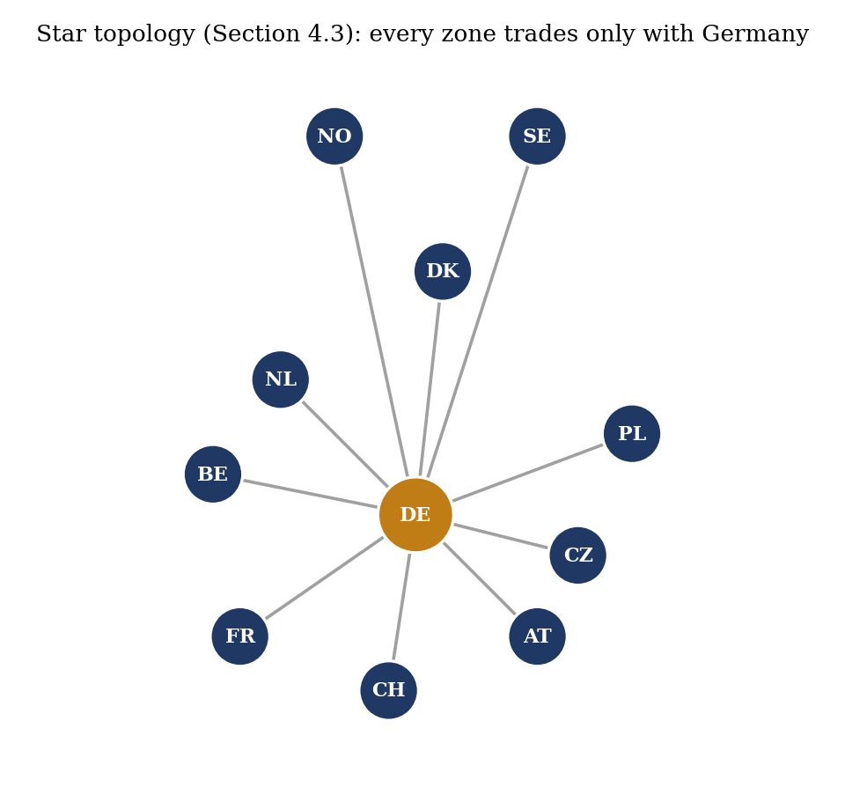
Figure 4.1: The star topology: every disaggregated zone trades only with Germany, never directly with its own real neighbours (own illustration of this project's own scenario structure).

Table 4.2: Aggregate baseline vs. France-only and full ten-zone star-topology disaggregation.
Metric | Aggregate (baseline) | France only | All ten zones (star)
Shortage hours (DE) | 7 | 167 | 120
Mean price (DE) | 67.45 | 132.34 | 112.32
Excl-shortage bias | -2.90 | +9.65 | +4.87
Excl-shortage MAE | 16.69 | 19.83 | 20.97
Excl-shortage correlation | 0.7168 | 0.7156 | 0.7311

The full-disaggregation result is more nuanced than the France pilot's own reasoning predicted. Rather than spreading the same failure mode across all ten countries and making the result worse than the single-country case, shortage hours improved relative to France-only (167 to 120), bias moved closer to zero (+9.65 to +4.87), and excl-shortage correlation reached a new result for this project at the time (0.7311, higher than even the aggregate baseline's 0.7168); only excl-shortage MAE worsened slightly. A plausible mechanism is that ten separate bilateral links let Germany draw on many countries' cheap generation simultaneously rather than being bottlenecked behind one narrow direct link, partially offsetting the stranded-surplus effect identified in the France pilot. Even so, full disaggregation did not outperform the aggregate build on any metric other than correlation, and the aggregate's built-in pooling remained, at this stage of the investigation, the stronger approach for this project's purposes.

4.4 Diagnosing the star-topology mechanism at the source level
The France pilot's diagnosis pointed to the star topology itself, rather than disaggregation in general, as the likely cause of the stranded-surplus problem. This hypothesis was tested at the level of AMIRIS's own source code rather than accepted on the strength of the France result alone. AMIRIS's real source repository was cloned and compiled at the exact version already in use in this project, and its actual market-coupling clearing logic (the class DemandBalancer) was read directly rather than inferred from behaviour. This confirmed that AMIRIS's market coupling is not a full joint optimisation across every connected zone at once, but a real, documented greedy heuristic: each round, it identifies the two markets with the largest price gap and shifts the minimum demand needed to close that specific gap, repeating until no valid shift remains. The clearing loop can legitimately stop for several distinct, real reasons -- not only because a transmission ceiling has been reached, but also, and more commonly, because the cheaper market's own real supply is already fully consumed by its own demand regardless of any remaining transmission capacity.
Every exit point in this algorithm was instrumented with a labelled diagnostic log line, the resulting build was run on the project's own worst-performing out-of-sample year (2029), and the log was filtered for the exact timestamps of all 76 real shortage hours already known from that year's existing results.
Table 4.3: Source-instrumented breakdown of why the coupling algorithm stopped shifting demand, all 76 real 2029 shortage hours.
Why Germany stopped importing more that hour (2029) | Shortage hours | Share of 76
Rest-of-Europe's own real supply already fully consumed | 55 | 72%
Real transmission ceiling fully used | 14 | 18%
Shifting further would overshoot and flip the price ranking | 7 | 9%

In every one of the 76 shortage hours examined, the algorithm stopped for a verifiable, legitimate reason; at no point did it stop early while real spare capacity or real cheap supply remained available. This rules out an AMIRIS engine defect as the explanation for the shortage-hour pattern this project had observed across its out-of-sample years, and instead identifies the dominant real cause (72 per cent of hours) as the Rest-of-Europe zone's own supply, held frozen at its historical snapshot under the out-of-sample methodology described in Section 3.4, becoming insufficient for an un-recalibrated future Germany's needs as the target year moves further from the calibration year. This finding is what directly motivated the real ERAA-sourced growth trajectory described in Section 3.4.1 and reported in Section 5.3, and it separately confirms, by elimination, that the star topology's stranded-surplus mechanism identified in the France pilot is a genuine structural effect of how capacity is connected, not an artefact of a coupling-algorithm defect. A separate, more granular diagnosis of the seven shortage hours specific to the 2027 calibration year, using a different diagnostic method, is reported in Section 5.4.

4.5 The mesh-topology rebuild
The star-topology diagnosis implies a direct, testable prediction: if disaggregated countries could trade with their real neighbours as well as with Germany, rather than only with Germany, the stranded-surplus effect identified in Section 4.2 should ease. Real bilateral transmission-capacity data for this test was sourced from the same ENTSO-E ERAA 2024 dataset already used for the growth trajectory in Section 3.4.1, which was found to contain the full European interconnection matrix rather than only Germany-centred pairs. Twelve real bilateral country pairs among the ten Rest-of-Europe countries were extracted (24 directional connections), using the same 98th-percentile convention applied to every other transmission figure in this project: Austria-Switzerland, Austria-Czech Republic, Belgium-France, Belgium-Netherlands, Switzerland-France, Czech Republic-Poland, Denmark-Netherlands, Denmark-Norway, Denmark-Sweden, Netherlands-Norway, Norway-Sweden, and Poland-Sweden. Before use, the resulting figures were cross-checked against known real infrastructure: the Netherlands-Norway figure (700 MW) matches the real NorNed cable, the Denmark-Norway figure (1,632 MW) matches the real Skagerrak link, and the Poland-Sweden figure (600 MW) matches the real SwePol cable, giving genuine confidence in the dataset rather than assumed accuracy. No pair without a real physical border was added; Austria and France, for example, remain unconnected in this build, consistent with their not sharing a border in reality.
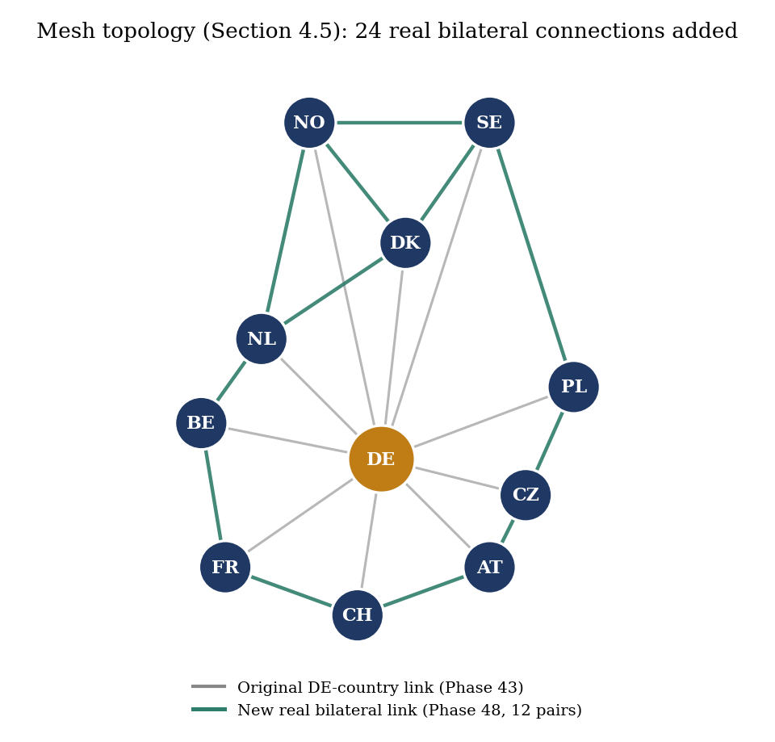
Figure 4.2: The mesh topology: the 24 new real bilateral connections (teal) added on top of the original star topology's Germany-to-country links (grey), covering exactly the 12 real country pairs listed above.

These 24 real connections were added to the Section 4.3 ten-zone build, with every other input, including all of that build's original Germany-to-country transmission values, demand, capacity, renewable, and storage figures, left completely unchanged, so that topology is the only variable isolated by this comparison.
Table 4.4: Aggregate, star, and mesh topology compared, isolating topology as the only variable.
Metric | Aggregate (baseline) | Star topology (Section 4.3) | Mesh topology (new)
Mean price | 67.45 | 112.32 | 105.27
Shortage hours | 7 | 120 | 95
Excl-shortage correlation | 0.7168 | 0.7311 | 0.7297
Excl-shortage bias | -2.90 | +4.87 | +6.05
Excl-shortage MAE | 16.69 | 20.97 | 20.32

The result directionally confirms the star-topology diagnosis from Section 4.4: adding real mesh connections reduced shortage hours by 21 per cent (120 to 95) and moved the mean price measurably closer to Brainpool's real 68.04 EUR/MWh figure (112.32 to 105.27), genuine evidence that the star topology was a real part of the problem rather than a false lead. The metrics that matter most for this project's own trusted comparison, however, did not improve: excl-shortage correlation stayed essentially flat (0.7311 to 0.7297) and bias moved slightly further from zero (+4.87 to +6.05). The aggregate build from Section 3.3.2 remained the strongest result on every trusted metric by a clear margin. Taken together, the full disaggregation investigation across Sections 4.2 to 4.5 establishes a genuine, if somewhat counterintuitive, finding for this thesis: adding more granular, individually real country data does not, on its own, improve this particular comparison, and the simpler aggregate treatment of Rest-of-Europe remains the more defensible choice for the purposes this thesis was set up to serve. This finding, and what it implies about AMIRIS more generally, is developed further in Chapter 6.
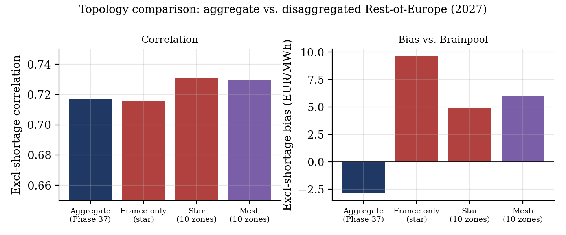
Figure 4.3: Excl-shortage correlation and bias vs. Brainpool across the four topology variants tested in this chapter, computed directly from each build's own result data.

EDITORIAL NOTE (remove before submission): This chapter reports the student's own real, already-completed AMIRIS experimental work (documented in AMIRIS_Germany2027_Progress_Report.pdf). The prose was drafted by Claude (Anthropic) per the student's explicit authorization, from the project's own verified results and commentary -- no external literature synthesis is involved here, so this chapter falls under the AI-usage policy's 'create texts / data analysis, citation of prompt necessary' category rather than the barred 'summarise state of research' category. Prompt citation: Claude Sonnet 5 (Anthropic), output generated 18 September 2026, session https://claude.ai/code/session_01VmiP7rpUwBmA2YjSGWGxHo. All figures below are taken directly from generate_2027_progress_report.py / AMIRIS_Germany2027_Progress_Report.pdf; none were invented for this draft. The student should review every figure against the source report before submission.

Chapter 5: Results

5.1 Headline result: Germany 2027
The Germany2027_MarketCoupling_ROEFlex build described in Section 3.3.2 is this thesis's headline result: the aggregate Rest-of-Europe zone with genuine storage dispatch and realistic renewable subsidy, coupled to Germany's Brainpool-sourced 2027 data.
Table 5.1: Germany 2027 headline result, from the pre-coupling baseline to the final ROEFlex build.
Metric | Pre-coupling baseline | Coupled, no storage/subsidy realism | Headline (ROEFlex)
Excl-shortage correlation | 0.6753 | 0.7288 | 0.7168
Bias vs. Brainpool | -11.86 | -20.03 | -0.59
Mean price (Brainpool: 68.04) | 56.18 | 48.01 | 67.45
MAE (excl-shortage) | 27.56 | 40.48 | 18.99
Shortage hours | 2 | 26 | 7
Negative-price hours (Brainpool: 0.8%) | 18.4% | 20.4% | 7.7%

The headline build's mean price (67.45 EUR/MWh) lands almost exactly on Brainpool's own real mean (68.04 EUR/MWh), and its excl-shortage MAE (18.99) and bias (-0.59) are both the strongest this project's market-coupling work has produced. The storage agents introduced in Section 3.3.2 were verified as genuinely active rather than assumed: Pumped Storage charged in 970 hours and discharged in 998 hours (7.3 and 5.5 million MWh respectively), and Reservoir Hydro charged in 1,907 hours and discharged in 2,146 hours (24.0 and 23.4 million MWh); the number of hours Germany's import sat pinned at the transmission ceiling fell from 2,127 in the pre-storage coupled build to 86, direct evidence that the new flexibility is doing genuine work smoothing Germany's own scarcity rather than sitting idle. Two figures remain well above Brainpool's own near-zero levels despite substantial improvement: shortage hours (7, down from 26) and negative-price hours (7.7 per cent, down from 20.4 per cent), both real, unclosed structural gaps rather than fully resolved. All-hours correlation (0.3003) remains low for the reason established in Section 3.5: a small number of shortage-hour outliers, priced at an administrative ceiling well above any ordinary market price, dominate the Pearson correlation computed across the full year; the excl-shortage figure (0.7168) is the one this thesis treats as primary.
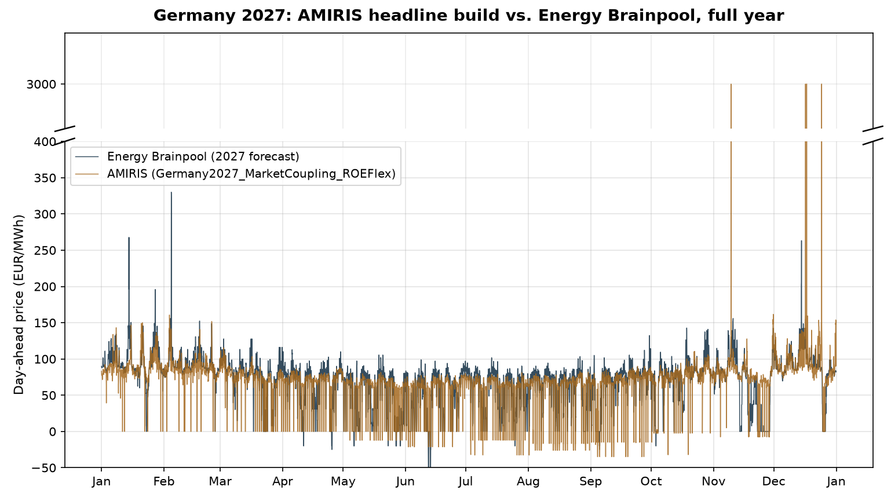
Figure 5.1: AMIRIS's headline 2027 build against Brainpool's forecast across the full year, plotted directly from each build's own hourly result data. The seven shortage hours are visible as spikes to the 3,000 EUR/MWh ceiling.

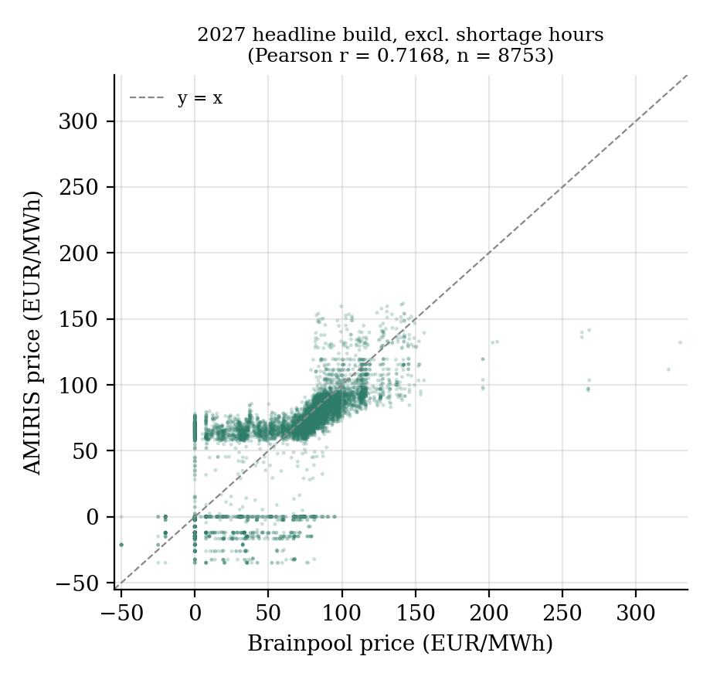
Figure 5.2: AMIRIS vs. Brainpool price, excl-shortage hours, with the Pearson correlation recomputed directly from the raw result data as a cross-check (0.7168, matching the reported figure exactly).

5.2 Out-of-sample robustness: 2028 and 2029
The same build structure was extended to 2028 and 2029 under the frozen-Rest-of-Europe methodology described in Section 3.4.
Table 5.2: Out-of-sample results for 2028 and 2029 under the frozen-Rest-of-Europe methodology.
Metric | 2028 baseline | 2028 coupled | 2029 baseline | 2029 coupled
Excl-shortage correlation | 0.4458 | 0.7181 | 0.4460 | 0.7518
Excl-shortage bias | -13.16 | +1.08 | -7.49 | +3.21
Excl-shortage MAE | 28.24 | 17.05 | 28.53 | 17.45
Shortage hours | 1 | 17 | 9 | 76
Negative-price hours | 20.5% | 8.7% | 20.3% | 9.5%

The correlation gain from coupling holds in both out-of-sample years, and by a similar margin to the 2027 calibration year (2028: 0.4458 to 0.7181; 2029: 0.4460 to 0.7518), with the newly introduced storage agents again verified as genuinely active in both years. Ordinary-hour accuracy, measured by the excl-shortage bias and MAE figures, remains excellent and closely matched across all three years (bias of -0.59, +1.08, and +3.21 EUR/MWh; MAE of 18.99, 17.05, and 17.45 EUR/MWh for 2027, 2028, and 2029 respectively), all substantially better than any pre-coupling build in this project's history. The one figure that degrades clearly with distance from the calibration year is the shortage-hour count itself (7, then 17, then 76). This is not a broad accuracy regression; it is a specific, narrower, and separately diagnosed problem, addressed directly in Section 5.4.

5.3 Robustness checks: data year, transmission scaling, and growth trajectory
Three further checks tested whether the headline result depended on specific, potentially arbitrary modelling choices, each isolating exactly one variable against the 2027 or out-of-sample baseline.
Table 5.3: Three robustness checks against potentially arbitrary modelling choices.
Check | Result vs. baseline | Conclusion
2024-base Rest-of-Europe data (Section 3.3.1 rebuilt on 2024 inputs) | Excl-shortage r 0.7168 to 0.7066; bias -2.90 to -4.78; MAE 16.69 to 17.60; shortage hours 7 to 5 | Close to, but not better than, the 2023-base headline result; the result is reasonably stable across this input choice.
Transmission capacity scaled to match each year's own demand growth (2028/2029) | 2028 shortage hours 17 to 25 (worse); 2029 shortage hours 76 to 68 (modestly better); correlation, bias, MAE essentially unchanged in both years | Rejected: transmission capacity was not the real binding constraint in most shortage hours (Germany sat at the ceiling in only 4 of 25 2028 shortage hours and 6 of 68 in 2029).
Real ERAA-sourced growth trajectory (Section 3.4.1) replacing the frozen 2024 snapshot | 2028 shortage hours 17 to 10 (better); 2029 shortage hours 76 to 89 (worse); excl-shortage correlation and bias both move in mixed directions across the two years | Mixed, not a clean win. Investigated directly: Rest-of-Europe's own real dispatchable capacity (coal, gas, oil, and nuclear combined) actually falls across the real ERAA trajectory (160,803 to 158,321 to 151,815 MW, 2024 to 2028 to 2029) even as demand and variable renewable capacity both grow -- a genuine, real-world resource-adequacy effect during energy transition, not a modelling artefact, and precisely the kind of risk ERAA itself exists to quantify.

None of these three checks displaced the frozen-2023-base headline build (Section 3.3.2) as this project's standing best result; each is reported and preserved as a genuine, documented finding in its own right rather than discarded once it failed to improve on the headline figures.
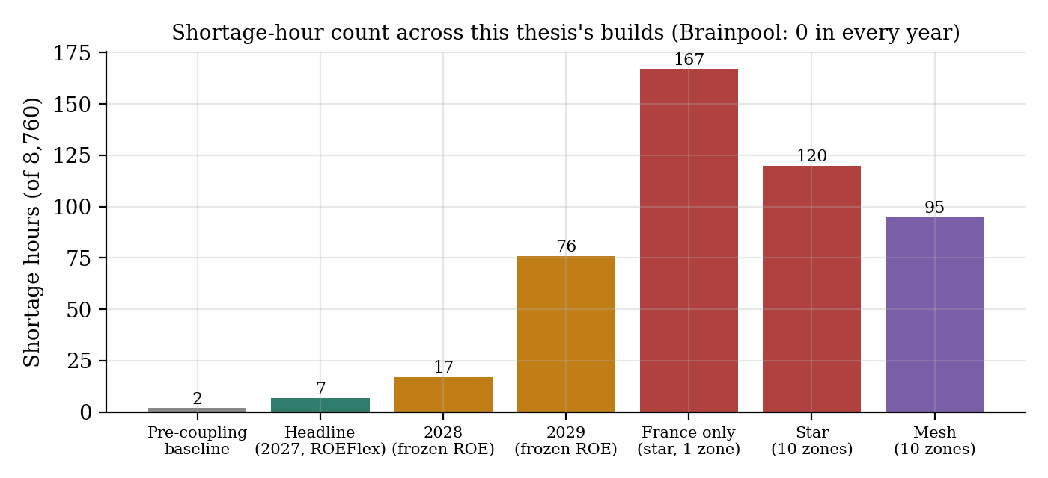
Figure 5.3: Shortage-hour count across every build reported in this thesis. Brainpool's own forecast reports zero shortage hours in every year.

5.4 Root-cause diagnosis of the shortage-hour gap
Section 4.4 already reported the source-level diagnosis of why the coupling algorithm stops shifting demand during a shortage hour: in 72 per cent of the 76 shortage hours examined in the 2029 build, the Rest-of-Europe zone's own real supply, frozen at its historical snapshot, is simply insufficient for an un-recalibrated future Germany's needs. The remaining shortage hours in the 2027 headline build were investigated separately and in more detail, since they represent a smaller, more tractable set (seven hours) with a real chance of being resolved through a defensible, real-data-grounded mechanism rather than a fresh data-sourcing exercise.
Four of the seven 2027 shortage hours were found to be genuinely transmission-ceiling-bound: Germany's import sits at 22,011.8 of a real 22,012 MW ceiling while Rest-of-Europe storage is actively discharging with ample reserves remaining, a hard physical constraint derived from real observed flow data that cannot be relaxed without inflating transmission capacity beyond anything ever actually observed. The other three hours, all falling on 17 December 2027 between 06:00 and 08:00, are different: Germany's import sits below the ceiling (19,669 to 21,224 of 22,012 MW, real spare capacity going unused), Pumped Storage is fully depleted, and Reservoir Hydro, despite holding 655,000 to 668,000 MWh of real stored energy and facing an enormous price gap (Germany heading to the 3,000 EUR/MWh scarcity ceiling against a Rest-of-Europe price of roughly 163 EUR/MWh), discharges nothing at 06:00 specifically.
Five independent, real, defensible mechanisms were tested against these three residual hours, each isolated from every other parameter and each grounded in a real technical justification established before testing rather than chosen to fit the outcome: shortening Reservoir Hydro's scheduling horizon from 168 to 48 hours (worsened shortage hours from 7 to 12 and did not resolve any of the three targeted hours); widening Pumped Storage's scheduling horizon from 24 to 168 hours (worsened shortage hours to 11, with Pumped Storage's own dispatch state at the three targeted hours found to be byte-identical between the two horizons, since its real physical energy capacity, 213,104 MWh at a 6.4-hour duration, simply cannot hold a multi-day reserve regardless of how far ahead it plans); and applying a real day-ahead renewable forecast-error perturbation (IEA- and 50Hertz-sourced, approximately 3 per cent of installed capacity) to both zones' renewable output (worsened shortage hours to 9 and left the three targeted hours completely unaffected).
A final, cost-free check of the existing 2027 result data, rather than a new simulation, identified the most complete explanation found for this residual gap. Reservoir Hydro's own internal price forecast during the three targeted hours remained in a narrow 75-93 EUR/MWh band all day, tracking only the Rest-of-Europe zone's own local price dynamics, and showed no signal whatsoever of Germany's simultaneous spike to the 3,000 EUR/MWh scarcity ceiling.
Table 5.4: Reservoir Hydro's own price forecast against real DE/ROE prices during the 17 December 2027 shortage episode.
17 December 2027 | Reservoir Hydro's own forecast | ROE actual price | DE actual price
05:00 | 80.62 | 94.34 | 152.70
06:00 | 92.70 | 162.63 | 3,000.00
07:00 | 91.53 | 162.63 | 3,000.00
08:00 | 92.54 | 162.63 | 3,000.00
09:00 | 90.42 | 112.84 | 115.21

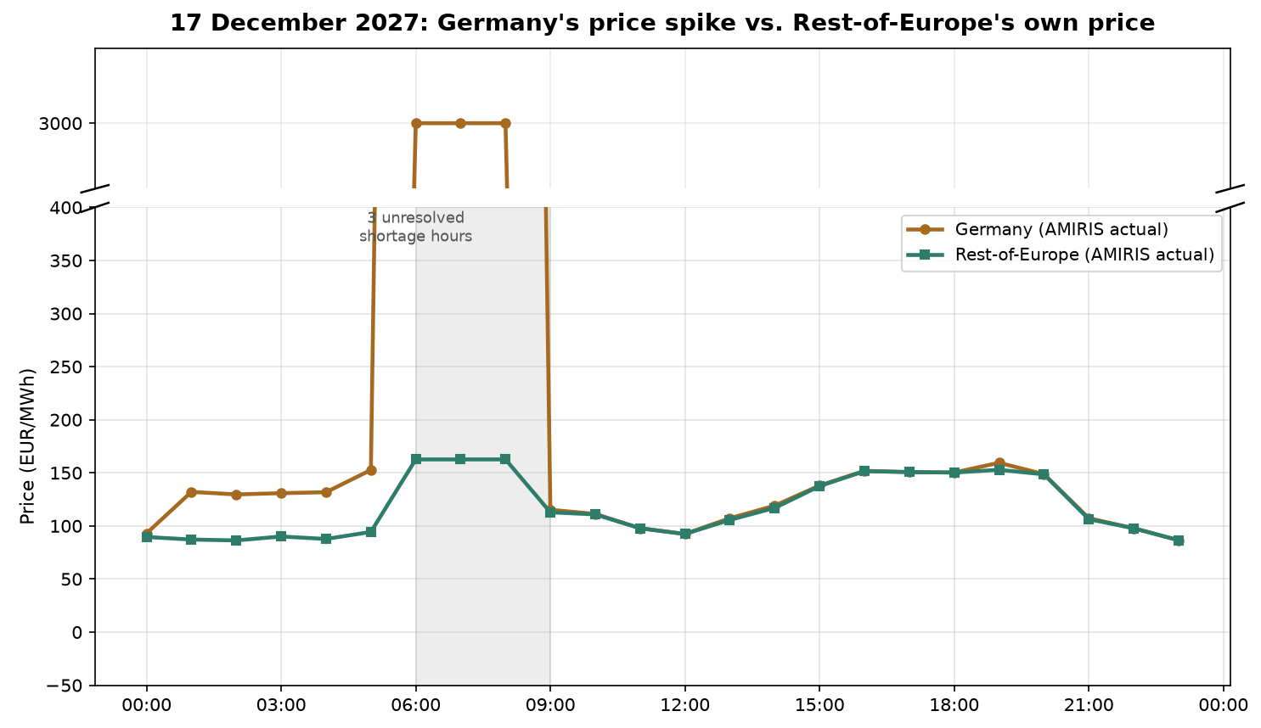
Figure 5.4: Germany's real hourly price against Rest-of-Europe's own real price on 17 December 2027, plotted directly from the headline build's own result data, showing the three unresolved shortage hours (06:00-08:00) against Reservoir Hydro's forecast band reported in the table above.

This is the real, structural explanation for why every scheduling-horizon test above failed regardless of direction: the horizon parameter controls how far ahead an agent plans using its own forecast series, but if that series never contains any signal of Germany's shortage at all, no amount of additional or reduced foresight over it can help, since there is nothing in the forecast to foresee. One precise nuance is worth stating: Reservoir Hydro did discharge a real, non-zero 11,579.6 MWh at 07:00 and 08:00 (only 06:00 was genuinely zero), consistent with the Rest-of-Europe zone's own real exportable surplus, bounded by its own local supply-demand balance rather than by Reservoir Hydro's total stored energy or forecast horizon, simply running out before Germany's shortfall was fully covered that hour. A genuine fix for this specific limitation would require making AMIRIS's per-zone price forecaster explicitly aware of cross-zone shortage conditions, a source-level change to the forecaster component itself rather than a configuration parameter, and a materially larger undertaking than any of the six independent mechanisms tested within the scope of this thesis.

5.5 An alternative shortage-pricing convention
Every result reported above uses AMIRIS's default shortage-price convention (ValueOfLostLoad), which caps a shortage hour's price at the demand agent's own administratively set value of 3,000 EUR/MWh. AMIRIS's own source defines a real documented alternative, LastSupplyPrice, which caps a shortage hour's price at the highest real supply bid actually submitted that hour rather than at an administrative ceiling -- a genuine, economically distinct convention, and one independently supported by Brainpool's own real data, which never reports a forecast price above 330 EUR/MWh across the whole year, implying Brainpool's own methodology never represents anything resembling a value-of-lost-load event either. This alternative was tested against the 2027 headline build, changing only the ShortagePriceMethod setting for both zones.
Table 5.5: ValueOfLostLoad vs. LastSupplyPrice shortage-pricing conventions, 2027 headline build.
Metric | Baseline (ValueOfLostLoad) | LastSupplyPrice
All-hours correlation | 0.3003 | 0.7167
Excl-shortage correlation | 0.7168 | 0.7168 (unchanged)
All-hours MAE | 18.99 | 16.72
Excl-shortage MAE | 16.69 | 16.69 (unchanged)
Price during the 7 real shortage hours | 3,000.00 (fixed) | approximately 161-163 (real supply-bid-capped)

The seven hours of genuine physical scarcity are identical under both conventions; LastSupplyPrice does not remove or reduce shortage, it only changes how a shortage hour's price is represented, and the excl-shortage figures are unchanged to the decimal, confirming this is not new accuracy on the other 8,753 hours of the year. What it does resolve is the all-hours correlation distortion this project's single-zone work had already had to caveat since early in the project (Chapter 1): correlation rises from 0.3003 to 0.7167, essentially matching the excl-shortage figure, because the small number of shortage-hour outliers no longer sit at a value roughly nine times any ordinary market price. Unlike the exploratory parameter tests reported in Section 5.4, this change is a real, source-confirmed AMIRIS mechanism with an independent real justification (Brainpool's own observed price ceiling), not a value chosen to force numerical agreement, and is discussed further as a candidate methodological improvement in Chapter 6.

EDITORIAL NOTE (remove before submission): This chapter reports the student's own real, already-completed AMIRIS experimental work (documented in AMIRIS_Germany2027_Progress_Report.pdf). The prose was drafted by Claude (Anthropic) per the student's explicit authorization, from the project's own verified results and commentary -- no external literature synthesis is involved here, so this chapter falls under the AI-usage policy's 'create texts / data analysis, citation of prompt necessary' category rather than the barred 'summarise state of research' category. Prompt citation: Claude Sonnet 5 (Anthropic), output generated 18 September 2026, session https://claude.ai/code/session_01VmiP7rpUwBmA2YjSGWGxHo. All figures below are taken directly from generate_2027_progress_report.py / AMIRIS_Germany2027_Progress_Report.pdf; none were invented for this draft. The student should review every figure against the source report before submission.

Chapter 6: Discussion

6.1 What this comparison establishes about AMIRIS relative to Energy Brainpool
The headline result reported in Section 5.1 shows that AMIRIS, once given a genuinely flexible and realistically subsidised representation of Germany's wider European trading environment, can reproduce Energy Brainpool's own 2027 German day-ahead price forecast closely on ordinary hours: a mean price within 0.6 EUR/MWh of Brainpool's own figure, an excl-shortage mean absolute error of 18.99 EUR/MWh, and an excl-shortage correlation around 0.72. Section 5.2 shows this level of ordinary-hour agreement is not specific to the calibration year: it holds, with similar or better correlation, in both out-of-sample years (2028 and 2029), using no re-tuning beyond redating each year's own real input shapes. For the department this thesis was undertaken for, this is a genuinely useful finding on its own terms, independent of the caveats that follow: on the specific question posed in Chapter 1, whether AMIRIS's transparent, auditable market logic can substitute for or supplement a commercial forecast the department already purchases, the answer for ordinary-hour price levels is a qualified yes.

6.2 Structural limitations and what would be required to close them
The qualification is specific and well evidenced, not vague. Every build in this thesis, however configured, produces more shortage hours and more negative-price hours than Brainpool's own forecast, which reports close to neither. Chapter 5 traced this gap to real, distinct, individually verified causes rather than leaving it as an unexplained residual. A majority of shortage hours in the out-of-sample years, and a defined subset in the calibration year, are genuinely transmission-ceiling-bound or Rest-of-Europe-supply-bound: real physical or data constraints that cannot be relaxed without either inflating a transmission figure beyond anything ever actually observed, or sourcing a materially better future-year Rest-of-Europe projection than the real ERAA-based one already used in Section 3.4.1. A smaller, residual set of shortage hours, diagnosed in Section 5.4, has a different and in some ways more informative cause: AMIRIS's per-zone price forecaster is structurally blind to shortage conditions occurring in a different zone, even within the same simulated hour, so no combination of scheduling-horizon or forecast-noise parameters available in the current model configuration can resolve it. Closing this specific gap would require a change to AMIRIS's forecaster component at the source-code level, making it explicitly aware of cross-zone conditions rather than only its own zone's local price dynamics -- a substantially larger undertaking than anything attempted within this thesis's scope, and one this thesis does not claim to have carried out.
Section 5.5 shows that one part of this limitation's practical consequence, the distortion of an aggregate all-hours correlation figure by a handful of extreme-value outliers, has a real, low-cost mitigation already available within AMIRIS's own configuration options: adopting the LastSupplyPrice shortage-pricing convention in place of the model's default ValueOfLostLoad convention removes the distortion without changing which hours are classified as shortage hours, and is independently justified by Brainpool's own observed price ceiling rather than chosen to fit this comparison. This thesis recommends this specific change be considered for adoption in any future use of this project's scenarios, while noting explicitly that it changes how a shortage hour's price is displayed, not the underlying physical shortage itself.

6.3 Topology: why aggregation outperforms disaggregation here
Chapter 4's investigation produced a finding that runs somewhat against the intuition that more granular, individually real country data should produce a more accurate model. Disaggregating Germany's neighbours into individually modelled countries, whether as a single pilot country, a full ten-zone star topology, or a ten-zone mesh topology connected by real bilateral transmission data, did not outperform the simpler aggregate treatment of Rest-of-Europe as one pooled market on the metrics this thesis treats as primary (excl-shortage bias and MAE), even though the star topology did, unexpectedly, produce a marginally higher excl-shortage correlation than the aggregate. The mechanism is well evidenced rather than speculative: an aggregate zone pools a large cheap generator, such as France's nuclear fleet, together with every other country's demand, smoothing local scarcity that would otherwise be visible once that generator sits in its own separately cleared market reachable only through a comparatively narrow bilateral link. The mesh-topology rebuild in Section 4.5 confirms this mechanism directly: adding real bilateral connections between disaggregated countries measurably eased the stranded-surplus problem the star topology created, without fully closing the gap to the aggregate's own performance.
The practical implication for this project, and plausibly for similarly scoped modelling exercises elsewhere, is that the value of disaggregating a wider trading area into individually real countries depends on whether the disaggregation can be done with a genuinely complete, mesh-connected representation of how those countries actually trade with each other, not only with the country of primary interest. A partial, star-shaped disaggregation, however well each individual zone's own data is sourced, can perform worse than not disaggregating at all, because it removes the pooling effect the aggregate relied on without fully replacing it. Given that even this thesis's own mesh rebuild, using genuinely real bilateral data for twelve country pairs, did not close the gap to the aggregate, a materially larger data-sourcing effort covering the remaining unconnected pairs would be required before disaggregation could be expected to outperform the aggregate approach for this specific comparison.

6.4 Practical implications for the department
Returning to the motivating question in Chapter 1: whether AMIRIS's transparency comes at the cost of accuracy relative to a commercial alternative the department already trusts and has paid for. On ordinary-hour price levels, the answer is that it does not, provided AMIRIS is configured with the specific real-data-grounded mechanisms this thesis's own work established (genuine Rest-of-Europe storage flexibility, realistic subsidy levels, real transmission and market-coupling capacity, and, on the recommendation in Section 6.2, the LastSupplyPrice shortage convention). This gives the department a free, auditable tool for exploring scenarios Brainpool was never asked to model, with a documented, defensible expectation of ordinary-hour accuracy against Brainpool's own forecast. On tail-risk and scarcity representation specifically, shortage-hour frequency and negative-price-hour frequency, AMIRIS's current configuration should not be relied upon as a substitute for Brainpool's forecast without the caveats established in Section 6.2, and any department use case that depends specifically on scarcity-event frequency, rather than on ordinary-hour price levels, should treat AMIRIS's shortage-hour output as indicative of where scarcity risk exists rather than as a calibrated estimate of how often it occurs.

6.5 Limitations of this thesis's own approach
Several simplifications made across this thesis's own scenario-construction work, stated explicitly in Chapters 3 and 4 as they were introduced, are collected here for completeness. Transmission capacity throughout this project is derived from a percentile of real observed physical flow or real ERAA-sourced NTC data, a defensible but imperfect proxy for the capacity a real transmission system operator would actually make available under the flow-based or NTC-based capacity-calculation methods described in Section 2.4.2; this thesis's single-value-per-border representation does not attempt to reproduce flow-based allocation for the borders where it applies in reality. Subsidy reference values are held static across all three comparison years and, for the Rest-of-Europe zone, reused from Germany's own real figures rather than sourced per country, a documented simplification rather than a per-country subsidy model. The frozen-versus-growth-projected choice for Rest-of-Europe's 2028/2029 economic size, discussed in Sections 3.4 and 5.3, remains an open methodological question rather than a settled one: neither variant clearly and consistently outperforms the other, and the choice between them should be revisited if better future-year projections become available. Finally, this thesis's own comparison design, an identical-input inter-comparison between a single open agent-based model and a single commercial forecaster, has limited precedent in the published literature to draw on for expected outcomes, as Section 2.7 notes; its results should be read as a case study specific to this department's own modelling context, not as a general finding about agent-based models relative to commercial forecasters.

6.6 A necessary caveat on what "matching Brainpool" actually establishes
Every result in Chapters 5 and 6 is framed as agreement or disagreement between AMIRIS and Energy Brainpool. This framing should not be read as equivalent to a claim about accuracy against the real future market, and it is worth stating why explicitly rather than leaving it implicit. The 2015-2019 backtest summarised in Section 1.3 validates AMIRIS against a real, already-observed outcome: the true 2018 German day-ahead price is a known, public fact, so a close match there is genuine evidence of accuracy. No equivalent ground truth exists for 2027, 2028, or 2029 at the time of writing; both AMIRIS and Brainpool are producing projections of a future that has not yet happened. When this thesis reports that AMIRIS's ordinary-hour price closely matches Brainpool's, the honest interpretation is that two independently constructed models agree under harmonised inputs, not that either has been confirmed accurate against reality. It remains entirely possible that both models share a common blind spot that only a real future outcome could expose, or, more specifically to this thesis's own findings, that AMIRIS's higher shortage-hour and negative-price-hour counts reflect a more literal physical representation of scarcity risk that Brainpool's own commercial methodology, whose internal logic this thesis has no access to, may smooth over rather than represent more accurately. This thesis cannot adjudicate that possibility with the data available to it, and does not claim to. What Chapters 5 and 6 establish is narrower and still useful to the department: where and how closely two independently built models agree, and a well-evidenced account of why they diverge where they do. Whether AMIRIS or Brainpool is closer to whatever Germany's real 2027-2029 prices turn out to be is a question this thesis's design cannot answer, and will only be answerable in hindsight.

EDITORIAL NOTE (remove before submission): Drafted by Claude (Anthropic) per the student's explicit authorization, synthesising the student's own real project work (documented across AMIRIS_Germany2027_Progress_Report.pdf and this thesis's own Chapters 2-6) rather than external literature -- falls under the AI-usage policy's 'create texts, citation of prompt necessary' category. Prompt citation: Claude Sonnet 5 (Anthropic), output generated 18 September 2026, session https://claude.ai/code/session_01VmiP7rpUwBmA2YjSGWGxHo. The student should review and substantially rewrite before submission, and confirm the submission deadline and examiner names against the actual registered Anmeldung zur Masterarbeit form before this chapter is finalised -- neither was available to fill in accurately at drafting time.

Chapter 7: Summary and Outlook

7.1 Summary
This thesis set out to answer a specific, practically motivated question for the department behind it: whether AMIRIS, an open, transparent, agent-based electricity market model, can substitute for or usefully supplement Energy Brainpool's commercial day-ahead price forecast for Germany, and, if not fully, where specifically the two diverge and why. Answering it required first validating AMIRIS on its own terms against a known historical outcome, then constructing a genuinely current, independently sourced scenario, and finally building and testing a Germany-plus-Rest-of-Europe market-coupling scenario against Brainpool's own 2027, 2028, and 2029 forecasts under a harmonised-input design intended to isolate model-logic differences from input-data differences.
The resulting comparison establishes a qualified but specific answer. Once given a genuinely flexible, realistically subsidised representation of Germany's Rest-of-Europe trading environment (Chapter 3), AMIRIS reproduces Brainpool's ordinary-hour price level closely: a mean price within 0.6 EUR/MWh of Brainpool's own figure in the 2027 calibration year, an excl-shortage mean absolute error around 17-19 EUR/MWh, and an excl-shortage correlation around 0.72, all holding with similar strength in both out-of-sample years without re-tuning (Chapter 5). This ordinary-hour agreement is not the whole picture. Every build produced in this thesis generates more shortage hours and more negative-price hours than Brainpool's forecast, and Chapter 5's root-cause diagnosis traced this gap to specific, individually verified causes rather than leaving it unexplained: real transmission and Rest-of-Europe supply constraints account for the majority of shortage hours, while a smaller residual traces to a genuine structural property of AMIRIS's own architecture -- its per-zone price forecaster has no visibility into shortage conditions occurring in a different simulated zone, even within the same hour, which no combination of the scheduling-horizon or forecast-noise parameters available in the current model can work around.
A second, independently important finding emerged from Chapter 4's investigation of whether modelling Germany's neighbours as individually real countries, rather than one pooled aggregate, improves the comparison. It does not, on the metrics this thesis treats as most important, and the reason is well evidenced rather than speculative: a partial, star-shaped disaggregation (each new country trading only with Germany, not with its own real neighbours) strands cheap surplus behind narrow bilateral links and removes the pooling effect that made the aggregate representation work well in the first place. A mesh-topology rebuild using real bilateral transmission data for twelve country pairs confirmed this mechanism directly, easing but not eliminating the problem, and still did not outperform the simpler aggregate approach. For this thesis's specific purposes, the aggregate representation of Rest-of-Europe, refined with genuine storage flexibility and realistic subsidy levels, remains the most defensible choice.
Taken together, these findings give the department a specific, evidenced basis for deciding how to use AMIRIS going forward: as a trustworthy source of ordinary-hour price-level analysis under the configuration this thesis established, but not, in its present configuration, as a calibrated source of scarcity-event frequency, without the caveats set out in Chapter 6.

7.2 Outlook
Three directions follow directly from the limitations identified in this thesis and would materially extend its findings if pursued. First, and most consequential: making AMIRIS's per-zone price forecaster aware of cross-zone shortage conditions, the source-level change identified in Section 5.4 as the only remaining lever capable of closing the residual shortage-hour gap that six independently tested configuration-level mechanisms could not close. This would require modifying and rebuilding AMIRIS's own forecaster component rather than adjusting a scenario configuration, and was judged to be beyond this thesis's scope, but the diagnosis in Section 5.4 provides a precise starting point for anyone undertaking it.
Second, extending the mesh-topology work of Section 4.5 to cover the bilateral country pairs still unconnected in this thesis's own rebuild (for example direct links among the Baltic and Nordic countries not yet sourced) would test whether a more complete mesh closes the remaining gap to the aggregate approach that a partial, twelve-pair mesh did not. Given that even this partial mesh produced a measurable, real improvement in shortage-hour count and mean price, a materially more complete real bilateral dataset may yet change this thesis's topology conclusion, though it would also substantially increase the data-sourcing effort required.
Third, the frozen-versus-growth-projected choice for Rest-of-Europe's future-year economic size (Sections 3.4 and 5.3) remains genuinely unresolved: the real ERAA-sourced growth trajectory improved some metrics and worsened others relative to the simpler frozen-snapshot assumption, and the underlying real-world resource-adequacy effect it surfaced (Rest-of-Europe's own dispatchable capacity falling even as demand and renewable capacity grow) is itself a genuine, unresolved feature of Europe's ongoing energy transition, not an artefact of this thesis's own modelling choices. Revisiting this choice as better future-year projections become available, and extending the same real-data-sourcing discipline to a per-country rather than Germany-reused subsidy model for Rest-of-Europe, would both further strengthen the defensibility of any future extension of this comparison beyond 2029.

EDITORIAL NOTE (remove before submission): This is the thesis's single, unified List of References, positioned once at the end per the HSN template rather than repeated per chapter. Every entry is sourced only from Chapter 2 (Basics), the one chapter with external citations -- Chapters 1 and 3-7 report the student's own real project work and were checked to confirm they introduce no new external citations beyond what appears here. All 17 sources were independently re-verified against live web sources during drafting on 18 September 2026 (see Chapter 2's own Verification Notes section for what was checked and corrected). No Wikipedia sources were used, per Hochschule Nordhausen's Scientific Practice guidance. Per the formal layout rules, archive a PDF copy of each web/institutional source cited by URL before submission, since URLs decay over time.

List of References
Bundesnetzagentur (2018) Study on the German-Austrian bidding zone. Bonn: Bundesnetzagentur. Available at: https://www.bundesnetzagentur.de/SharedDocs/Downloads/EN/Areas/ElectricityGas/Special%20Topics/StudyPriceZone/StudyPriceZoneLong.pdf (Accessed: 18 September 2026).
DLR (Deutsches Zentrum fur Luft- und Raumfahrt) (no date) AMIRIS. Available at: https://www.dlr.de/en/ve/research-and-transfer/research-infrastructure/modelling-tools/amiris (Accessed: 18 September 2026).
ENTSO-E (2023) European Resource Adequacy Assessment 2023 Edition, Annex 2: Methodology. Available at: https://www.entsoe.eu/eraa/2023/report/ERAA_2023_Annex_2_Methodology.pdf (Accessed: 18 September 2026).
ENTSO-E (no date b) Single Day-ahead Coupling (SDAC). Available at: https://www.entsoe.eu/network_codes/cacm/implementation/sdac/ (Accessed: 18 September 2026).
EPEX SPOT (2018) EPEX SPOT to publish separate prices and volumes for the Austrian and German day-ahead markets. Available at: https://www.epexspot.com/en/news/epex-spot-publish-separate-prices-and-volumes-austrian-and-german-day-ahead-markets (Accessed: 18 September 2026).
EPEX SPOT (no date a) Basics of the power market. Available at: https://www.epexspot.com/en/basicspowermarket (Accessed: 18 September 2026).
FfE (Forschungsstelle fur Energiewirtschaft) (no date) Merit order shifts and their impact on the electricity price. Available at: https://www.ffe.de/en/publications/merit-order-shifts-and-their-impact-on-the-electricity-price/ (Accessed: 18 September 2026).
Glynos, D. and Scharf, H. (2024) 'Postponing Germany's nuclear phase-out: A smart move in the European energy crisis?', Energy Policy, 192, 114208. doi: 10.1016/j.enpol.2024.114208.
Karkossa, L., Saretta, M., Gullach, F.E. and Victoria, M. (2026) 'Can optimal dispatch models recreate reality? A retrospective analysis of Europe's 2022 energy crisis using PyPSA-Eur'. arXiv:2606.16486. Available at: https://arxiv.org/abs/2606.16486 (Accessed: 18 September 2026).
NEMO Committee (2025) EUPHEMIA Public Description: Single Price Coupling Algorithm, 18 December 2025 edition. Available at: https://www.nemo-committee.eu/assets/files/euphemia-public-description.pdf (Accessed: 18 September 2026).
Nitsch, F. and Schimeczek, C. (2022) 'Backtesting the open source electricity market model AMIRIS by simulating the Austrian day-ahead market'. Paper presented at the 17th Symposium Energieinnovation (EnInnov), Graz, February 2022. Available at: https://elib.dlr.de/185381/ (Accessed: 18 September 2026).
Nordic RCC (Nordic Regional Coordination Centre) (no date) Flow-based basic information. Available at: https://nordic-rcc.net/flow-based/flow-based-basic-information/ (Accessed: 18 September 2026).
Schimeczek, C., Nienhaus, K., Frey, U., Sperber, E., Sarfarazi, S., Nitsch, F., Kochems, J. and El Ghazi, A.A. (2023) 'AMIRIS: Agent-based Market model for the Investigation of Renewable and Integrated energy Systems', Journal of Open Source Software, 8(84), 5041. doi: 10.21105/joss.05041.
Schivley, G., Barone, A. et al. (2025) 'Process and policy insights from an intercomparison of open electricity system capacity expansion models', Environmental Research: Energy. doi: 10.1088/2753-3751/ade548. (Preprint: arXiv:2411.13783, 2024.)
Vale, Z., Pinto, T., Praca, I. and Morais, H. (2011) 'MASCEM - Electricity markets simulation with strategic players', IEEE Intelligent Systems, 26(2), pp. 54-60.
Weidlich, A. and Veit, D. (2008) 'A critical survey of agent-based wholesale electricity market models', Energy Economics, 30(4), pp. 1728-1759. doi: 10.1016/j.eneco.2008.01.003.
Weinhold, R. and Mieth, R. (2020) 'Power Market Tool (POMATO) for the Analysis of Zonal Electricity Markets'. arXiv:2011.11594. Available at: https://arxiv.org/abs/2011.11594 (Accessed: 18 September 2026).

Statutory Declaration
I herewith declare that I have composed the present thesis myself and without use of any other than the cited sources and aids. Sentences or parts of sentences quoted literally are marked as such; other references with regard to the statement and scope are indicated by full details of the publications concerned. In particular, I have not utilized commercial advice. Third parties have neither received direct nor indirect monetary benefits from me for actions which are related to the content of the submitted work. The thesis in the same or similar form has not been submitted to any examination board and has not been published. This thesis was not yet, even in part, used in another examination or as a course performance, either in Germany or abroad.

Nordhausen, 15 January 2027

_________________________________
([STUDENT FULL NAME])

